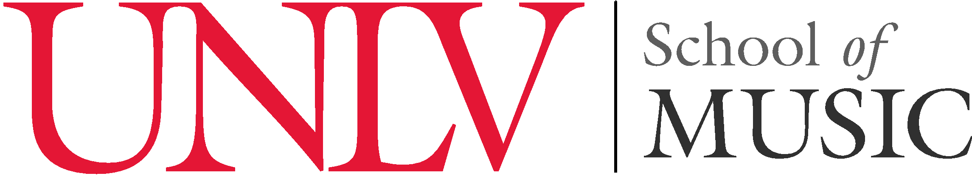
College of Fine Arts presents a

Senior Recital
Mark McCreery, baritone
Cindy Lee, piano

PROGRAM

From Messiah G.F. Händel
“But Who May Abide the Day of His Coming?” (1685-1759)

Il fervido desiderio Vincenzo Bellini Dolente immagine di Fille mia (1801–1835)
Vaga luna, che inargenti

INTERMISSION

Aus meinen grossen Schmerzen Robert Franz Die blauen Frühlingsaugen (1815–1892)
Auf dem Meere
Si mes vers avaient des ailes Reynaldo Hahn
À Chloris (1874–1947)

Plenty Good Room arr. Donald Moore
Deep River arr. H.T. Burleigh
Ev’ry Time I Feel de Spirit (1866-1949)

This recital is presented in partial fulfillment of the requirements for the degree
Bachelor of Music in Performance.

Mark McCreery is a student of Dr. Kimberly James.

Monday, November 05, 2018 5:30pm Dr. Arturo Rando-Grillot Recital Hall
Lee and Thomas Beam Music Center
University of Nevada, Las Vegas

