This document explains how to use the Add/Update Degree Form to submit a new degree or certificate to the Degrees Directory. The Degrees Directory is a database of academic information that provides current and consistent information throughout UNLV’s academics site and other UNLV websites. It pulls this content from the catalog: Description if there is one, Admissions Requirements, Course Requirements, Degree Requirements, and Graduation Requirements.

In an effort to standardize degree information and satisfy accreditation requirements, the following checklist provides the information required in order to submit a request. Consider printing this or using it electronically as a checklist.

If an incorrect file is attached, override it by submitting another file. To do this, click on the same "Upload file" button you used to upload the incorrect file, and select the correct file.

Undergraduate

When submitting degree requests for undergraduate degrees, be sure to have the following:

Official name as approved by the Board of Regents for degrees or certificates of 30 or more credits; Faculty Senate Curriculum Committee approval for certificates under 30 credits, minors, tracks, sub-plans, and concentrations.
- Description
  - Provide a description of the new degree or certificate. This is the place to sell the degree! You can include discussion of careers, ranking of the college/school or program, research strengths, etc.
  - Do not include: admissions information, deadlines, courses, graduation requirements.

Learning Outcomes
  - List student learning outcomes in bulleted or numbered format. Be sure the learning outcomes reflect what your students will know and/or be able to do by the end of the degree or certificate program. Use the Quick Guide to Writing High-Quality Course Learning Outcomes guide provided by the Office of Academic Assessment.
  - Have the learning outcomes approved by the Office of Academic Assessment and submit the approval email.

Career Information
  - If career possibilities are not in the description of the degree, describe here.

Degree Worksheets
Degree worksheets contain information on what courses are required in order to graduate from the program.
  - The Degrees Directory will display a maximum of 10 years of degree worksheets including the upcoming year for the degree.

Plans of Study

An academic plan of study provides a student and their advisor with a road map to help the student graduate in a timely manner.
- The Degrees Directory will display a maximum of 10 years of plans of study for the degree.

Representative Syllabi, 5 required
  - Provide five syllabi to represent the courses students will take throughout the program.
    - Include at least one introductory course and a capstone, thesis, dissertation course.
    - Include the course title and number in the file name.
    - Delete faculty name and contact information.
    - Ensure each syllabus complies with the Academic Year Memo, Syllabi Content and is current at the time of submission. The current Syllabi Content is here: https://www.unlv.edu/about/policies/current-policies in the Executive Vice President and Provost section.

Graduate
Information related to the following items will be populated directly from the catalog: plan description, plan admissions requirements, plan requirements, course requirements, degree requirements, and graduation requirements.

When submitting degree requests for graduate degrees or certificates, be sure to have the following:

Official name as approved by the Board of Regents for degrees or certificates of 30 or more credits; Graduate College Programs Committee approval for certificates under 30 credits, tracks, sub-plans, and concentrations.
- Description
  - Provide a description of the new degree or certificate. This is the place to sell the degree! You can include discussion of careers, ranking of the college/school or program, research strengths, etc.
  - Do not include: admissions information, deadlines, courses, graduation requirements.

Learning Outcomes
  - List student learning outcomes in bulleted or numbered format. Be sure the learning outcomes reflect what your students will know and/or be able to do by the end of the degree or certificate program. Use the Quick Guide to Writing High-Quality Course Learning Outcomes guide provided by the Office of Academic Assessment.
  - Learning outcomes must be approved by the Office of Academic Assessment and you must submit the approval email in this request.

Career Information
  - If career possibilities are not in the description of the degree, describe here.

Coordinator

Degree contacts
- Handbook
  - Graduate College approved handbook.

Representative Syllabi, 5 required
  - Provide five syllabi to represent the courses students will take throughout the program.
    - Please include at least one introductory course and a capstone course.
    - Include the course title and number in the file name.
    - Delete faculty name and contact information.
    - Ensure each syllabus complies with the Academic Year Memo, Syllabi Content and is current at the time of submission. The current Syllabi Content is here: https://www.unlv.edu/about/policies/current-policies in the Executive Vice President and Provost section.

How to Find the Link to Add to the Degrees Directory

Go to: https://www.unlv.edu/academics/degrees/units/education
Select any degree, minor, or certificate in the list and click on the little box at the very bottom right corner "Update Degree Info":

On the next page, go to the bottom of the right column and click on the box "Add/Update a Degree Entry".
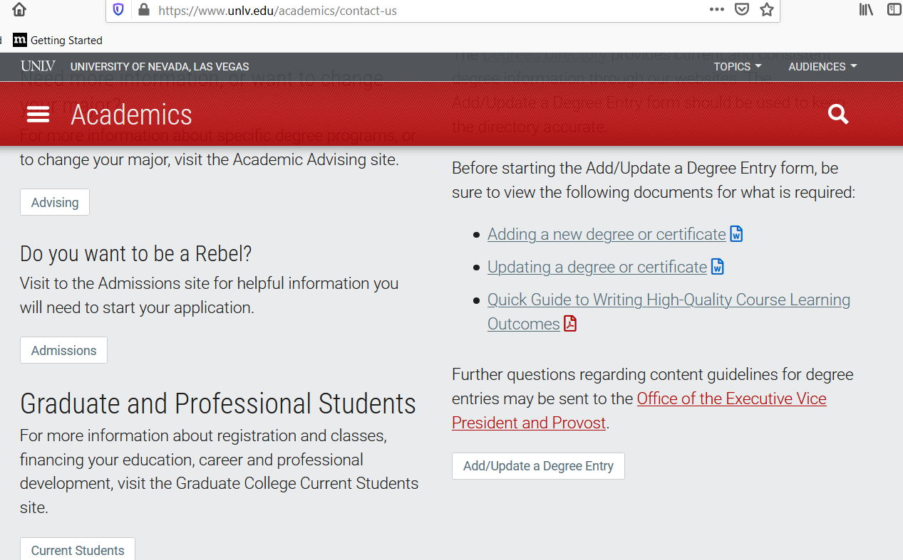

You are now in the form and can begin adding information.
