OFFICE OF THE REGISTRAR
FACULTY SENATE CURRICULUM COMMITTEE
Catalog Course Authorization
Minor/Concentration Change
E-mail form to Curriculum@unlv.edu in the Registrar’s Office.
Save file as minor/concentration name followed by minorcr (e.g., XXXXminorcr).

I. Routing Information
Contact Name: |  |  |  |  |  |  |  | Department and Prefix:
Contact’s e-mail address: |  |  |  |  |  |  |  | College:
II. Effective Date
Semester change should become effective:

Catalog year change becomes effective:
III. Minor/Concentration Information
College: |  |  |  |  |  | Department/School:
Minor: |  |  |  |  |  | Concentration:
Justification for minor/concentration change:

Click on the HTML area only.

TRANSCRIPT_HARDCOPY_NOP Request w/ hardcopy not Printd
TRANSCRIPT_HARD_COPY Request with hard copy hold
TRANSCRIPT_LIST_DETAILS Official request details
TRANSCRIPT_LIST_NOTPRT Official requests not printed
TRANSCRIPT_OTH_COUNTRY Other country; for cleanup
TRANSCRIPT_SERV_IND Request with neg serv ind
TRANSCRIPT_SIGNAT_REQ Request with Signature Require
TRANSCRIPT_SPSHIP_NOPRT Special shipping not printed
TRANSCRIPT_STUREQ_HOLD Student requested hold

Open up TWO WINDOWS

Run the first query of the day
UNLVSR_TRANSCRIPT_OTH_COUNTRY- Other country; for cleanup

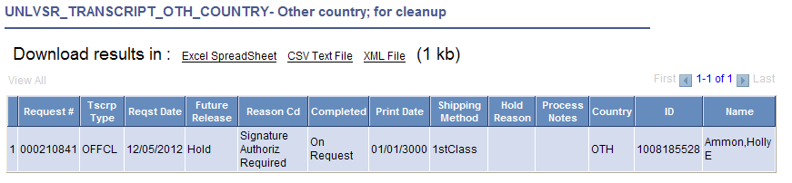
You will get to the request by clicking on
The transcripts are on HOLD until you fix the country code you need to first pull up the request then keep this address on one screen and open up the request again and retype the address.
Click on “SEND TO”
The Country Code states “OTH” you need to click on to get the correct country code
The example says FRA type FRA in the Country code to get the correct country. Click on the “Edit Address” Then type in the address again. Click OK ‘make sure the address looks correct. IF it’s not you can click on Edit Address again and make the correction. After everything is good click “SAVE”
Then go to the and click on ‘Hold’ and click on Immediate Processing

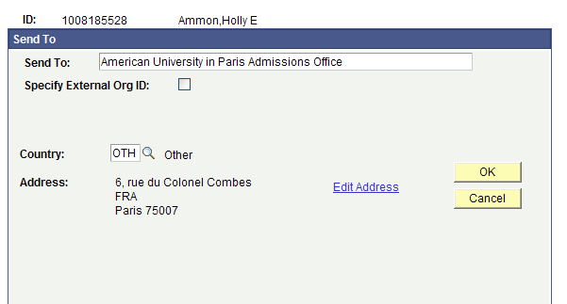
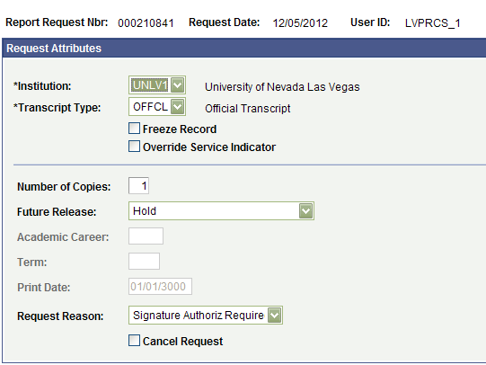

Minor/Concentration Requirements

Minor Concentration
Are you changing how students are admitted to the minor/concentration: Yes No
If yes, Describe:
Are you changing how students meet minor/concentration Core requirements: Yes No
If yes, Describe:
Are you changing how students meet minor/concentration elective requirements: Yes No
If yes, Describe:
Minor/Concentration Credits
It is the department’s responsibility to make certain all hours and totals are accurate.
Minor |  |  |  |  |  |  | Concentration
Number of Credits | Existing Hours |  |  | New Hours |  |  | Number of Credits: |  |  | Existing Hours |  | New Hours
Minor Required |  |  |  |  |  |  | Concentration Required
Minor Elective |  |  |  |  |  |  | Concentration Elective
Total Credits |  |  |  |  |  |  | Total Credits
IV. Endorsement/Approvals
Submit to Registrar’s Office and College Committee after obtaining Provost approval.
Department, College and Dean’s Approval
 |  | Yes | No |  | Name |  |  |  | Date |  | Comments
Department
College Committee
Dean’s Office
UNLV Check Area (Registrar’s Office)

 |  |  | Yes | No |  |  |  | Name | Date |  | Comments
Registrar - Curriculum
Degree Audit (TADA)
Faculty Senate Curriculum Approval
Curriculum Committee Chair |  |  | Yes | No |  |  |  | Agenda # | Date |  | Comments
V. Catalog Description:
(Faculty Senate Curriculum Committee will not discuss program without the new catalog text). Use the existing electronic catalog as a guide. Please provide current catalog text and the new catalog text. Assume this description below will be copied and pasted directly into the catalog. If the selection is too big for section V., scroll to the bottom of the document and copy and paste the information

Old Catalog Text:

New Catalog Text:

For use of the Registrar’s Office
 | Initials | Date |  |  | Comments
Acalog:

MyUNLV:
TADA:

Save file as program name followed by minorcr (e.g., XXXminorcr).
E-mail form to Curriculum@unlv.edu in the Registrar’s Office
Insert SECTION V. information below -

