Lee Business School International Ambassador Application



Dear Lee Business School International Ambassador Applicant:

Thank you for your interest in this program. By submitting your application, you enter a pool of candidates representing the most outstanding students within UNLV’s Lee Business School (LBS). These students are measured not only by GPA, but also by leadership, character, and community involvement.

LBS International Ambassadors participate in the Nevada Global Business Summer Study program; a partnership with UNR’s College of Business and Extended Studies. In summer 2018 we will be traveling to London, England from June 23rd to July 20th to study at the University of London. Students will earn six credits of upper-division business course work. Students chosen for this position will be of the highest caliber in order to represent UNLV’s Lee Business School abroad. In addition, International Ambassadors are responsible for marketing and recruiting for the program year round. International Ambassadors hold a unique position within the school, engaging with distinguished alumni, business leaders, and community partners.

To qualify for the LBS International Ambassador program, students must have at least junior standing, be admitted to a business major by the May before the program starts, and hold and maintain a minimum cumulative 3.0 GPA. All applicants must show strong involvement and leadership in at least one campus organization. In order to be considered for the program, please fill out the attached application. Once completed, submit the application, including all essays and professional references, to the front desk of BEH 100, the Business Advising Center or to Dana.Angioni@unlv.edu by October 13, 2017. After reviewing your application, a selection committee will schedule an interview with you. There are a limited number of spots available so apply early!

We look forward to reviewing your application. If you have any additional questions, please feel free to contact me directly.

Sincerely,

Dana Angioni, M.Ed
Program Coordinator
Lee Business School Ambassador Programs
Dana.Angioni@unlv.edu

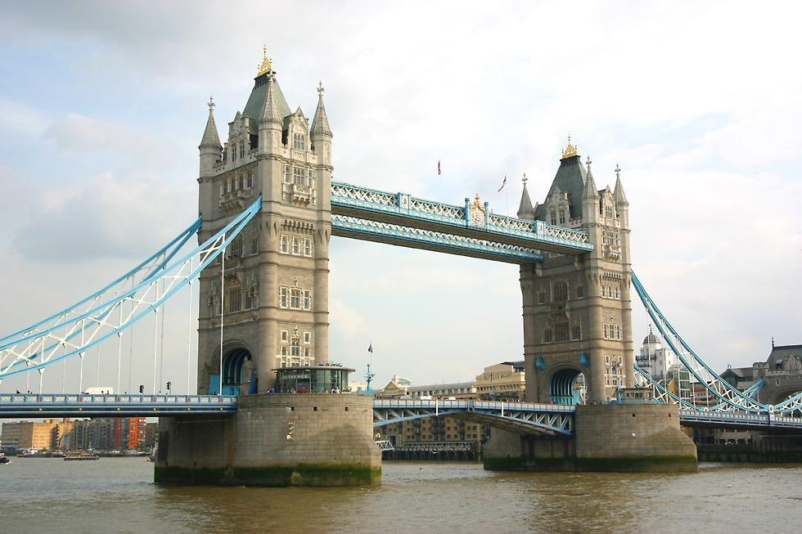

International Ambassador Applicant Information

Name: NSHE ID:

Rebelmail: Phone:

Address:

City NV Zip

Academic Information

College: Major:

Cumulative GPA: Class Standing/ Expected Graduation:

List of References: Please include three professional references; one must be a faculty member
(Someone you have taken a course from)

Name: Relationship to; Email: Phone:

1.

2.

3.

Essay Questions and Resume

Please thoroughly respond to the following questions in a separate document and attach it to this application. Your answers should be no more than two pages in length.

- Why are you interested in becoming an International Ambassador?
- What makes you an ideal student to represent the Lee Business School? Please include any leadership experiences, campus involvement, community service, etc.

*Please attach a current resume.

By signing this document you acknowledge that all of the information contained herein is true to the best of your knowledge.

Signature
e
Date
e

