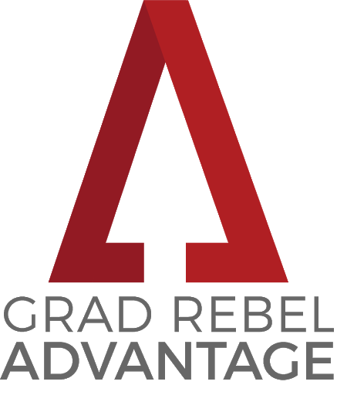

MENTOR APPLICATION

Student Instructions
Please complete this form electronically, type your name to sign, save the form, and route it via email to the faculty member who you have identified to endorse you for this program. Endorsers must be academic faculty at UNLV.

Endorser Instructions
Once you have completed the “Faculty Endorsement Information and Signature” of the form, please save the form and send it via email to GradRebelAdvantage@unlv.edu.

Applications are due to the Graduate College via email by Wednesday, April 8, 2020.

Note: If you are accepted as a Grad Rebel Advantage Mentor you must attend our kick-off breakfast event on in September; it will be mandatory for all participants and mentors.

For full program requirements and more information, please visit
https://www.unlv.edu/graduatecollege/institute/grad-rebel-advantage-program
 |  |  |  |  | Grad Rebel Advantage Program Mentor Application

Student Information
First Name: |  |  |  |  | Last Name: |  |  |  |  |  |  | NSHE ID:
Program: |  |  |  |  | Degree: |  |  |  |  |  |  | Rebelmail:
Phone: |  |  |  |  | Credits Completed: |  |  |  |  |  |  | Cumulative GPA:
Are you a student athlete? Yes No

Eligibility and Program Requirements
 | I am a current UNLV degree-seeking graduate student enrolled in at least 3 graduate-level credits, and in good standing (minimum 3.00 overall GPA). I have completed at least 12 graduate-level credits by the end of the past spring semester.
 | I understand that I must complete all of the program requirements outlined at unlv.edu/graduatecollege/institute/grad-rebel-advantage-program in order to receive the program benefits.

Statement of Interest

Describe why you are interested in serving as an Advantage Mentor (150 word max).

Student Signature

I certify that the information above is accurate and I agree to the terms and conditions of this program.
 |  |  |  | Student Electronic Signature |  |  |  |  |  |  | Date

Faculty Endorsement Information and Signature
Faculty/Advisor Electronic Signature |  |  |  |  |  |  |  | Title/Position |  |  |  |  |  |  | Date
GRADUATE COLLEGE USE ONLY
Accept into program? |  |  | Yes |  |  | No |  |  |  | Start Term:
Comments:

