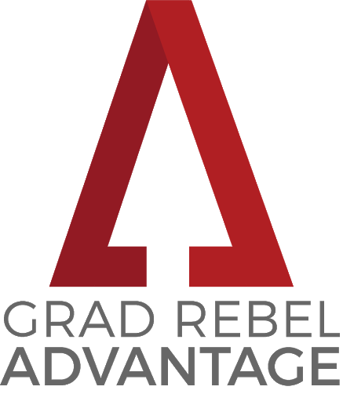

Student Instructions
Please complete this form electronically, type your name to sign, save the form, and route it via email to the faculty member who you have identified to endorse you for this program. Endorsers must be academic faculty or administrative faculty (such as an academic advisor) at UNLV.

Endorser Instructions
Once you have completed the “Faculty/Advisor Endorsement Information and Signature” of the form, please save the form and send it via email to GradRebelAdvantage@unlv.edu.

Applications are due to the Graduate College via email by 5:00 p.m.
on Wednesday, April 8, 2020.

Application Timeline and Information
Applications will be reviewed by a committee of Graduate College and Grad Rebel Advantage partner/sponsor faculty members. Decision emails will be sent to applicants’ Rebelmail email accounts during the week of May 25. Applicants will have 5 days from the date that their acceptance email is sent to you to respond and communicate your intent to participate in this program.

If you are accepted into the Grad Rebel Advantage program you must attend our kick-off breakfast event; it will be mandatory for all participants.

For full program requirements and more information, please visit
https://www.unlv.edu/graduatecollege/institute/grad-rebel-advantage-program
 |  |  |  |  |  |  |  | Grad Rebel Advantage Program Application Form

Student Information
First Name: |  |  |  |  |  |  |  | Last Name: |  |  |  |  |  |  |  |  | NSHE ID:
Major: |  |  |  |  |  |  |  | Minor: |  |  |  |  |  |  |  |  | Rebelmail:
Phone: |  |  |  |  |  |  |  | Credits Completed: |  |  |  |  |  |  |  |  | Cumulative GPA:
Are you a student athlete? Yes No
Are you a veteran? Yes No

Eligibility and Program Requirements
 |  |  | I am a current UNLV degree-seeking undergraduate student enrolled full-time (minimum 12 credits per semester), and in good standing (minimum 2.75 overall GPA). I have completed 60+ undergraduate credit hours by the end of the current semester.
 |  |  | I understand that I must complete all of the program requirements outlined at unlv.edu/graduatecollege/institute/grad-rebel-advantage-program in order to receive the program benefits.

Statement of Interest

Describe your short- and long-term career goals and explain why you are interested in this program (250 word max).

Student Signature

I certify that the information above is accurate and I agree to the terms and conditions of this program.
 |  |  |  |  |  |  | Student Electronic Signature |  |  |  |  |  |  |  |  | Date

Faculty/Advisor Endorsement Information and Signature
Applicants are required to have the endorsement of an academic advisor or faculty member to qualify for participation. The following questions are to be completed by the faculty member/academic advisor.
In what capacity do you know this applicant?
How long have you known this applicant?
For the following questions, please rate using a scale of 1 to 10 (1 = not likely, 10 = highly likely). Check the appropriate box to indicate your rating. |  |  |  |  |  |  |  |  |  |  |  |  |  |  | 1 |  |  | 2 | 3 |  |  | 4 | 5 |  |  | 6 | 7 |  | 8 | 9 | 10
a. | This program will have a significant, positive impact on this student.
b. | This student will successfully complete this program if accepted.
c. | This student will graduate from undergraduate program in a timely manner.
d. | This student will be successful in graduate school in the future.
Other comments you wish to provide about this applicant (optional):
 |  | I highly recommend |  |  | this applicant for the Grad Rebel Advantage Program.
 |  | I recommend
 |  | I do not recommend
Faculty/Advisor Electronic Signature |  |  |  |  |  |  |  |  |  |  |  | Title/Position |  |  |  |  |  |  |  |  |  |  |  | Date
GRADUATE COLLEGE USE ONLY
Accept into program? |  |  |  |  |  | Yes |  |  | No |  |  |  |  | Start Term:
Comments:

