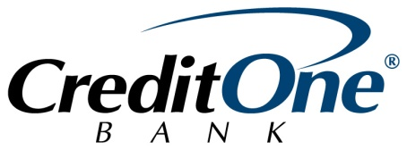

Request For Proposals
Credit One Bank is one of America's leading issuers of VISA® credit cards for individuals looking to establish or rebuild their credit. Based in Las Vegas, Nevada, Credit One Bank is highly committed to serving the credit needs of the local community, with a focus on those of low- to moderate- income. To help ensure a brighter financial future for everyone, Credit One Bank seeks to make a charitable reinvestment in programs that educate youth through financial literacy education and training. The goal of the program will instruct Clark County youth to help them better understand credit, build skills in how to use credit wisely, and how to avoid the pitfalls of excessive revolving credit. Grant funding of up to $50,000 may be awarded to one or more qualified non-profit organizations annually.
Priority will be given to organizations that have been in operation a minimum of two years, have an established program that provides financial literacy training for low- and moderate- income, within the age range of 12 - 19 years. Applicants will be required to communicate their organizational mission, program goals and metrics. It is recommended that applicants explain how their organization collaborates with other non-profit organizations within the community.
The Request for Proposals (RFP) will open February 22, 2017 and close March 31, 2017. Proposal packages must be received in their entirety by the due date. Late or incomplete submissions may be declined. Please direct any questions concerning this RFP to Tyrene West, GRANTWELL Senior Program Officer, grantwell.unlv@gmail.com.
Qualified proposals will include the following:
- Completed Grant Application
  - Section 1: Organization Information
  - Section 2: Program Summary
  - Section 3: Budget
- IRS Tax Exemption Letter 501(c)(3) status
- IRS Form 990, minimum last 2 years
- IRS W9
- List of officers and directors of the organization
- Authorization signature/ Acknowledgement: organization must provide a detailed accounting on use of any funds awarded

Send completed proposals to:
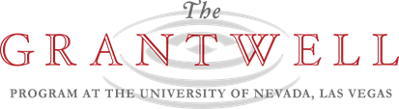

Electronic: grantwell.unlv@gmail.com
Postal: ATTN: GRANTWELL
Nonprofit, Community, and Leadership Initiative
401 S 4th Street Las Vegas, NV 89101

Grant Application
SECTION 1: ORGANIZATION INFORMATION
Name of Organization (include any DBAs currently in use): | Federal Tax Identification Number:
Full Address: | Telephone Number:
Website Address: | Primary Contact:
Contact: Telephone Number and Email Address: | Authorized Representative (Name and Title):

SECTION 2: PROGRAM SUMMRY
Please provide a detailed description of the proposed program:
Please explain your organization’s experience and qualifications in implementing financial literacy programming, specifically with youth:
Describe specifically how funds requested will be used, including the number of clients served:
Please describe how your program will support that primarily Low-Moderate Income (LMI) individuals will be recipients of any grant funds awarded:
How has your organization successfully demonstrated the ability to collaborate with other non-profits in the past? Please describe your collaboration efforts with the proposed funding, if any:
For program evaluation purposes, please provide a timeline that shows the activities you plan to pursue in chronological order:
Summarize how your organization will measure the success of the proposed program using the Logic Model provided.

Budget

- Dollar Amount of the request and provide a budget that details categories of expenditures that will be funded by the requested grant.

- What percent of the grant, if received, will go directly to program/services?

- Please provide a listing of top donors and funding sources.

- Summarize the current financial status of your organization. What are your major financial concerns for the current year and beyond? Is the organization a party to any lawsuits or claims? If yes, please explain.

