Exercise 1
Scenario
A worker needs the approval and funds set aside for a travel trip. They need this to be done in Workday so there is an audit trail. Create a Spend Authorization for the pre-travel.
Step | Data to Enter or Select
- Enter “Create Spend Authorization” or “Create Spend Authorization for Worker” in the task Search box. | Choose the worker the spend authorization is on behalf of if applicable
- Company automatically populates and can be changed to another company if the user has access to it  Select the Start Date and End Date you expect to incur this expense. | Company should auto populate to  (University of Nevada, Las Vegas)  Start Date: (01/20/2018)  End Date: (01/27/2018)
- Choose the Business Purpose that is most applicable: | For this Activity Choose:  - Business Purpose > Employee Out-Of-State Travel
- Enter the Destination of the trip in the Description field | (Flying to New York City, New York)
- Reimbursement Payment Type will be the form that will be distributed back to the employee. | This will default in. For this activity leave it as it defaulted.  If your worker requests something different options might be:  - Check  - Direct Deposit
- Enter the business purpose for trip or spend in the Justification field.  Everything related to Procurement Card will go in the Justification field as well. | Flying to NYC for ABC Convention  Paid on P-card:  - Airfare: $500  - Hotel: $1500
- On the Spend Authorization Lines tab, add expense transaction for the spend authorization by clicking button. | Click
- Choose the Expense Item by typing the word or clicking on the prompt After choosing an Expense Item. First thing the user should do is read the Instructional Text to see if this is the correct Expense Item to use for your purpose and how to enter the Item Details regarding this Expense Item.  When completing Spend Authorizations other options for searching for an appropriate item in the Expense Item box:  - By Spend Category Type: Each Expense Item is mapped to a Spend Category. Select what is most applicable to find your expense item  - By Alphabetic Order: List all Expense Items in Ascending Order  TIP: Daily Meal Per Diem – For Spend Authorization Only is the only expense item that should be used for meal per diem in a spend authorization | Depending on the Expense Item chosen the fields for the lines will change. We will use “Daily Meal Per Diem – For Spend Authorization Only” for this activity. The following instructional text will default in: 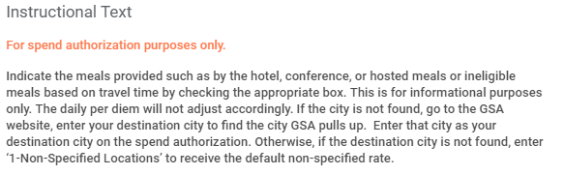  If you cannot not find the expense item by typing, the user can click on the prompt icon. Click on each of the following:  - Click  - By Expense Item Group  - Travel  - Daily Meal Per Diem – For Spend Authorization Only  *** Be aware there is an expense item group called “Itemization Purposes Only”. These items should only be used in Expense Reports after clicking the button. The button is not available in Spend Authorization.
- Enter the Quantity. | (Enter the number of days that the Daily Meal Per Diem should apply)  We will enter 7.75 for this Activity.  Note: The Per Unit Amount is based off the Destination field. If you cannot find the destination or the rate is incorrect. Please read the Instructional Text.  If you want an exact amount to display on the spend authorization, you may add decimals as a workaround.
- (Optional) Enter a Memo. | (Enter a memo for this specific expense item if applicable)  Example: The only meal provided was for a banquet at the Marriott Hotel
- If a Cash Advance Request is needed for this specific Expense Item. By checking the box, the user is requesting funds to be released to the worker on the spend authorization before the expenses have incurred. | For the Spend Authorization Activity leave this blank.  For the Cash Advance activity click on the box next to it.
- Enter the Primary Worktags and Additional Worktags.  Primary Worktags will have dedicated fields of their own. For example: Unit* and Cost Center* in this case.  Additional Worktags are where the rest of the worktags are entered.  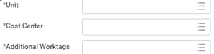 | The user should first delete the auto populated worktags that defaulted from the worker and then enter the Program, Gift, Grant, or Project in the Additional Worktags field for the related worktags to populate  For this activity, please enter Program/Project/Gift/Grant that you commonly use.  When you select or type in a Program, Gift, Grant, or Project, Workday automatically populates related worktag values from that value. Related woktags include Unit, Cost Center, Function, and Fund.  TIP: Use this link to access the WAX tool! This will help you populate the worktags within Workday! You will input your OLD objects and it will map to your NEW objects in Workday  https://wax.unr.edu
- Depending on the expense item for the line, complete Item Details. Reference the Instructional Text for help.  (* red asterisks are required to be filled out)  (Users may not know the details of the trip yet therefore the other fields are not required on the spend authorization. However, they will be required on the expense report) | Example Expense Item: Daily Meal Per Diem – For Spend Authorization Only  Departure Time: (When the Worker left for the trip)  Arrival Time: (When the Worker arrived back from the trip)  Destination*: (New York, NY, United States of America) – This will determine the Per Unit Amount  - (For informational purpose only – will not adjust amount here)  Number of Hours: (For eligibility - Full Day or Partial Day)  Number of Breakfast Provided: (5)  Number of Lunch Provided: (0)  Number of Dinners Provided: (0)
- Click the Trash Can or Minus Button to Delete a Spend Authorization Line if needed.
- On the Attachments tab, add or drop files that relate to the spend authorization by clicking the Select Files button. | (Add the pre-travel documents here)
- Clicking Save for Later will generate a expense report number or continue saving the users work.  Clicking Cancel will cancel all the changes the user has made thus far. | For this activity do not click either.
- Click Submit . | Click Submit. (This will kick off the next business process step)
- View your submission  Who is up next?  What is the spend authorization status?  View the Process tab to view history  View more options by clicking Actions | 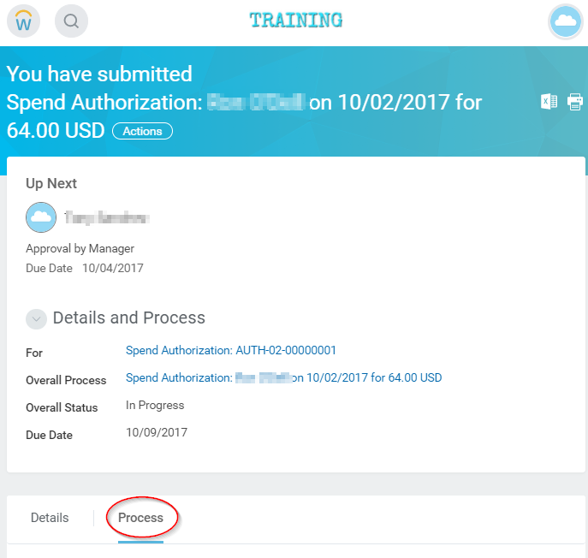
- Where is the Spend Authorization at in the current Process History? Click on the Process tab. | 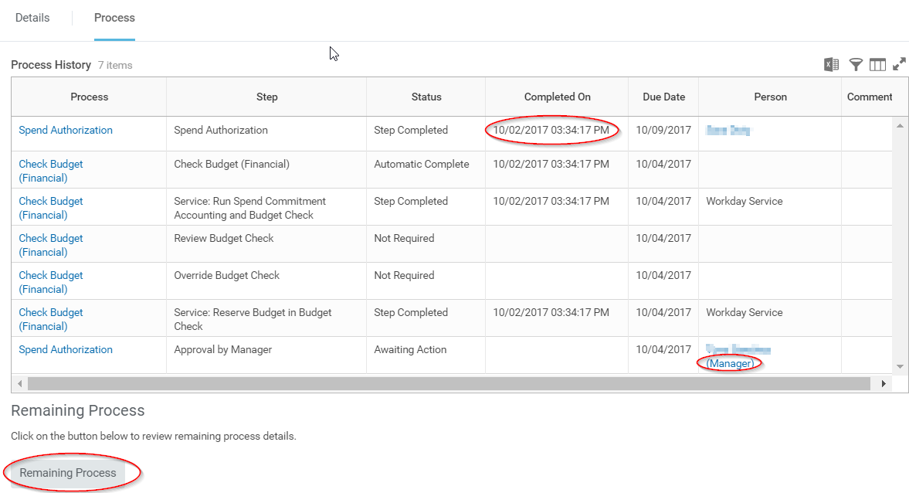
- Click on Remaining Process to view the potential next steps and users that will be responisble completeing the business process.that will be responisble completeing the business process.  How is the spend authorization routed?  - It depends on the worktag managers | 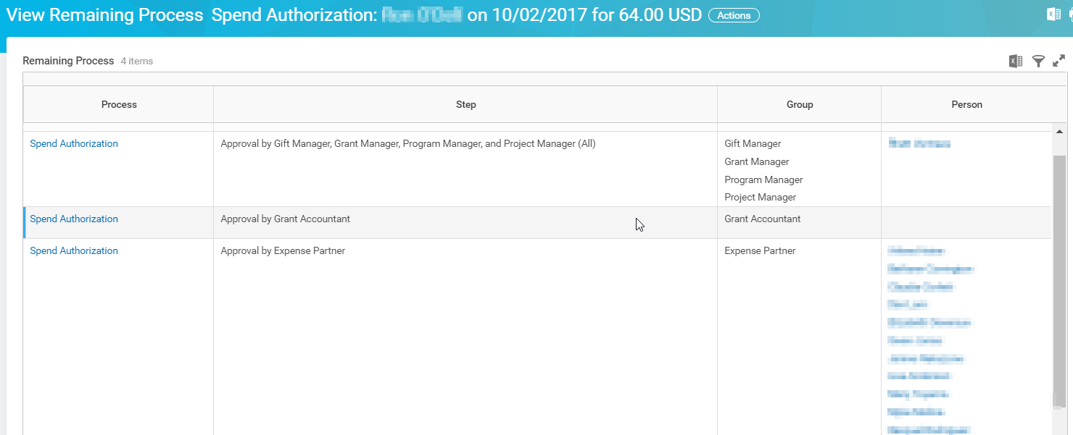
- Next Step: Find the Spend Authorization | How do you go back and submit, edit, or review a spend authorization?  Reports to run from Workday Search Bar:  - My Spend Authorizations (allows users to find their own)  - Find Spend Authorization Lines for Organization - FIN - SC (NSHE)  - AUTH-02- (will return all Spend Authorizations that the user has access to view)  - The Archive will capture everything you’ve Submitted
- How does the Approval look like? | 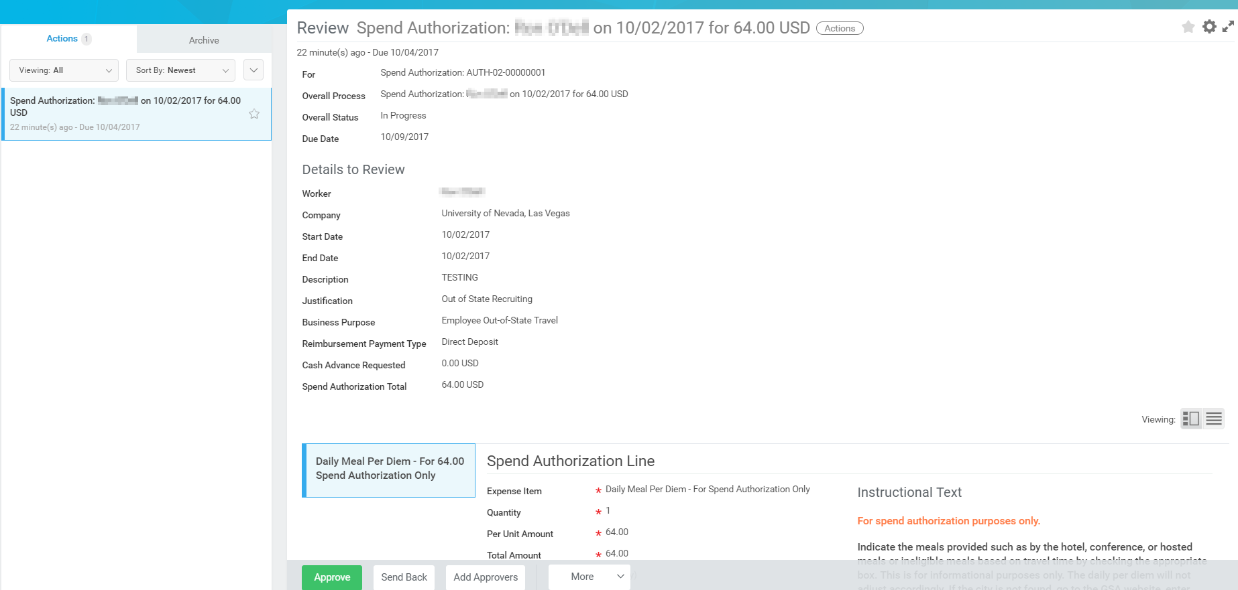
- How does a Completed Spend Authorization business process look like? | 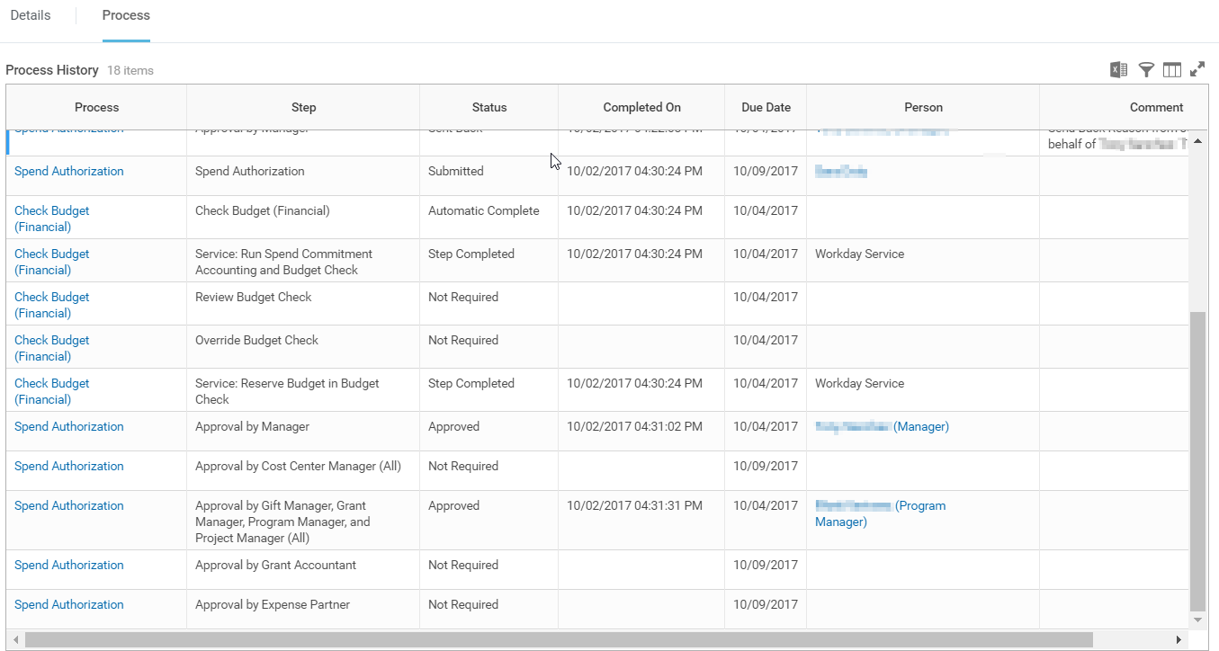

Notes:
Congratulations! You have completed this exercise.
End

Reference: Spend Authorization Statuses
This table describes the different statuses for a spend authorization.
Status | Description
Draft | You created a spend authorization but have not yet submitted it.  To update spend authorizations in Draft status, use the Edit Spend Authorization related action.
In Progress | You created and submitted a spend authorization but it has not yet been approved or denied.
Complete | The submitted spend authorization is approved. You can now incur the authorized expense and select this spend authorization in an expense report.
Denied | The submitted spend authorization is denied.

Frequently Asked Questions:

How are $0 Travel Documents being handled?

For the short term continue use paper form based authorization and keep these documents at the college/VP level. No entry is made in Workday. We are looking into a campus process going forward.

What are all the possible Business Purposes available?
- Employee In-State Travel
- Employee International Travel
- Employee Out-Of-State Travel
- General Academic Non-Travel
- General Administrative Non-Travel
- Group/Team In-State Travel
- Group/Team International Travel
- Group/Team Out-of-State Travel
- Moving Expense
- Pre-Hire Expense
- Student In-State Travel
- Student International Travel
- Student Out-of-State Travel
The following will produce an error if added to a Spend Authorization:
- Petty Cash/ Change Fund Establishment
- Petty Cash Replenishment

During the creation of an expense report, what is the status of and the accounting impact on a spend authorization when I select the Final Expense Report for Spend Authorization option?

Workday changes the status of your spend authorization to Closed after the linked expense report is approved. When the spend authorization is linked to multiple expense reports, Workday closes the spend authorization if you select this option on a non-canceled expense report and after you settle all linked expense reports.

How do I close a spend authorization?
Close spend authorizations to:
- Prevent further actions from occurring against the spend authorization.
- Update the spend authorization status to closed.
- Liquidate the remaining balance of the spend authorization (when you enable commitment accounting).
Close is available when a spend authorization doesn’t have an outstanding cash balance and is approved.

Steps:
- Select Spend Authorization > Close from the related actions menu of an approved spend authorization.
- Review transaction information to verify that you want to complete the close.

Result:
Workday liquidates the remaining balance on the spend authorization when business process activity is complete. After you settle the expense report, the status of the spend authorization changes to Closed.

