(ONLY FOR YOUR REFERENCE FROM DEMOSTRATION)
How to Create a Receipt off a Purchase Order:
Create Receipts are used to track receipt of goods or services against purchase orders or supplier contracts. Receipt details flow to applicable Accounts Payable staff to support the invoice process. Create Returns are used to track the return of goods or services that were not received or used to ensure these items do not get processed in Workday for payment to the supplier. Note: Upon receipt of the goods or service, the requisition requester will complete a receipt
Step | Data to Enter or Select
- Access your “My Requisitions” report.  Hover over the Purchase Order Number. Then click the Related Action button off the PO you want to create a receipt on. | 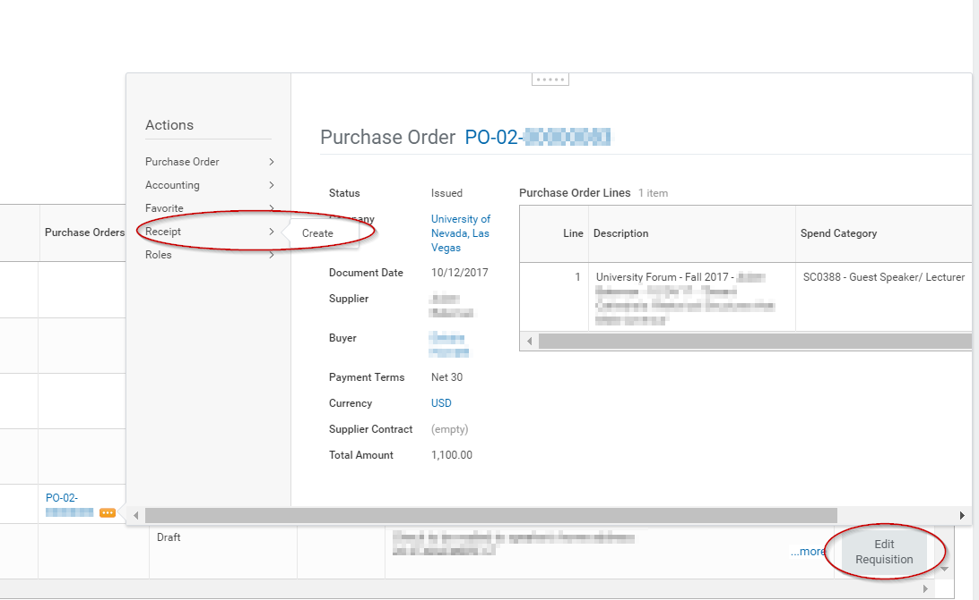
- Create Receipt page appears.  Purchase Order number or Supplier Contract information appears in the respective field. Click OK . | 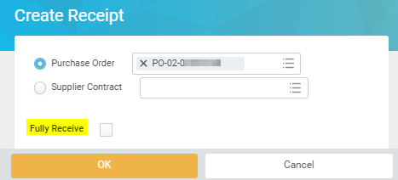  TIP: Enter a checkmark in the Fully Received box to receive remaining quantities or amounts on purchase orders or contracts without having to manually enter individual quantities or amounts on each line.
- Receipt Date defaults to current date. Modify the date if different than current date.  Complete Memo field, if applicable. | 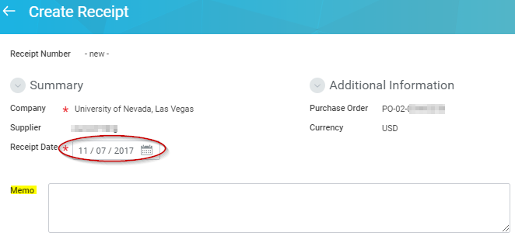
- Go to the Service Lines tab and change the Amount To Receive to the full amount if the service has been fully received or a partial amount for a partial service or whatever may be the case maybe. Change Memo field if needed.  If Save for Later button is clicked, status will display as Draft. If Submit button is clicked, status will display as Successfully Completed.  Click Submit . | 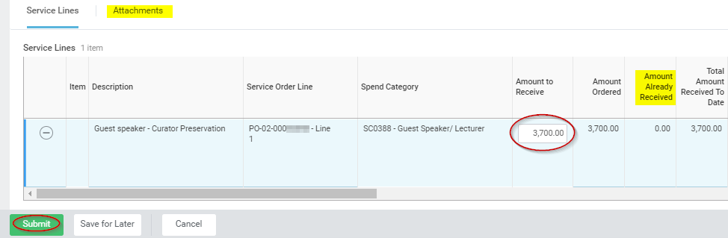
- Receipt Number and the Status of the receipt appear in top portion of the page. | 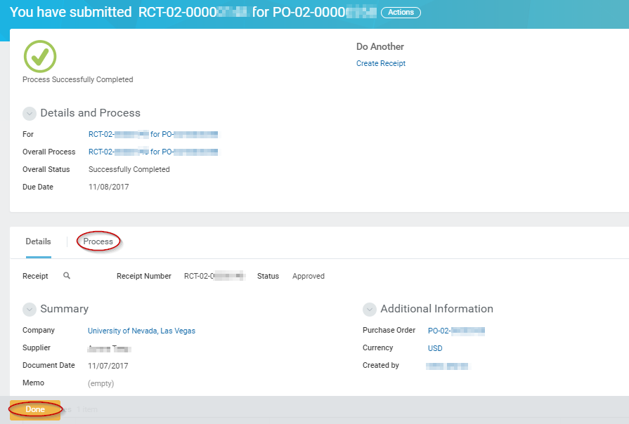
- How to View Existing Receipt  From Purchases worklet 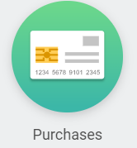on your Home page:  Click Receipts button.  If desired, use filters on My Receipts page and click OK .  Click the applicable receipt number in the Receipt column on My Receipt to view receipt details.  Click Process History sub-tab on View Receipts to check the history of the Receipt. | 