Exercise 2
Scenario
A worker has just come back from a business trip and is ready to be reimbursed. You will create an expense report post-travel for the worker.
Step | Data to Enter or Select
- Enter “Create Expense Report” or “Create Expense Report for Worker” in the task Search box.
- Enter the worker’s name in the Expense Report For field. | Choose the worker the Expense Report is on behalf of.
- Please read the instructional text. | 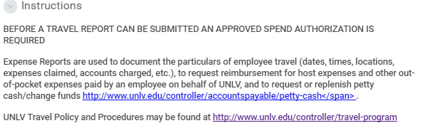
- Choose a Creation Option:  - Create New Expense Report: This should be chosen for after the fact purchases, meaning there was no spend authorization.  - Copy Previous Expense Report  - Create New Expense Report from Spend Authorization | For this Activity, choose Create New Expense Report.
- Company automatically populates and can be changed to another company if the user has security access to it. | Company should auto-populate to:  University of Nevada, Las Vegas
- Select the Expense Report Date you want to submit this expense report by. | Expense Report Date: 10/28/2018
- Enter the Primary Worktags and Additional Worktags.  Primary Worktags will have dedicated fields of their own. For example: Unit and Cost Center in this case.  Additional Worktags are where the rest of the worktags are entered.  Workday uses Worktags to identify data that tracks and drives your accounting.  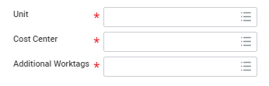 | The user should first delete the auto-populated worktags that defaulted from the worker and then enter the Program, Gift, Grant, or Project in the Additional Worktags field for the related worktags to populate.  For this activity, please enter Program/Project/Gift/Grant that you commonly use.  When you select or type in a Program, Gift, Grant, or Project, Workday automatically populates related worktag values from that value. Related worktags include Unit, Cost Center, Function, and Fund.  TIP: Use this link to access the WAX tool! This will help you populate the worktags within Workday. You will input your OLD objects and it will map to your NEW objects in Workday  https://wax.unr.edu
- Click OK.
- Choose the Business Purpose that is most applicable. | For this activity, use Business Purpose > Employee Out-Of-State Travel
- Reimbursement Payment Type is the form that will be distributed back to the employee. | This value will default in. For this activity leave it as-is.  If the worker would like a payment type different from the default options might be:  - Check  - Direct Deposit
- Information Only: Spend Authorization will appear here if the user had chosen “Create New Expense Report from Spend Authorization” from Creation Option.  A user can still choose a Spend Authorization if one is available for the worker. | We will leave this blank for this activity.
- Check the Final Expense Report for Spend Authorization box if there will be no more expense reports created that will be tied to the Spend Authorization above this field. | This will be unchecked for this activity.  Please note the importance of this box. This box will liquidate the entire amount of the associated Spend Authorization.
- Enter the business purpose for the trip or spend in the Memo field.  Everything related to Procurement Card will go in the Memo field as well. | Flying to San Francisco, California for XYZ Conference  Paid on P-card:  - Airfare: $500  - Hotel: $1500
- On the Expense Report Lines tab, add expense transaction for the spend authorization by clicking the button. | Click .
- Enter the Date of when the Expense Item was incurred. | 10/26/2017
- Choose the Expense Item by typing the word or clicking on the prompt . After choosing an expense item, the first thing the user should do is read the Instructional Text to know if this is the correct expense item to use for your purpose, and how to enter the Item Details regarding this expense item.  When completing spend authorizations, other options for searching for an appropriate item in the Expense Item box are:  - By Spend Category Type: Each Expense Item is mapped to a Spend Category. Select what is most applicable to find your expense item  - By Alphabetic Order: List all Expense Items in Ascending Order | We will use “Meal Per Diem - Daily” as an example. Depending on the Expense Item chosen, the fields for the lines will change. The following instructional text will default in: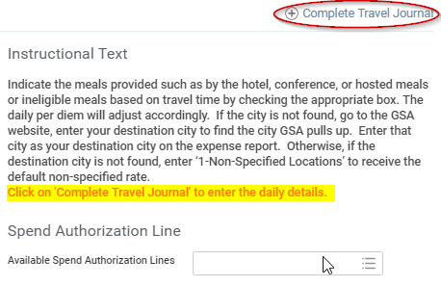  If you cannot not find the expense item by typing, you can click on the prompt icon. Click on each of the following:  - The prompt icon  - By Expense Item Group  - Travel  - Daily Meal Per Diem – For Spend Authorization Only  Note: There is an expense item group called “Itemization Purposes Only”. These items should only be used in Expense Reports after clicking the button. The button is not available in Spend Authorization.
- (Optional) Enter a Memo. This memo is going to be recorded on the line, so it should be specific to the line item. | For this activity type: The conference provided all lunches.
- This will auto-populate with the original worktags the expense report was created with from Step 7. If the cost of this expense is being taken out of another account, please change these worktags appropriately. | For this activity, we will use the Worktags populated from Step 7.  If you want to change this, please reference Step 7 for additional information.
- Depending on the expense item for the line, complete Item Details. Reference the Instructional Text for help.  (* red asterisks are required to be filled out)  Note: Users may not yet know the details of the trip; therefore, the other fields are not required on the spend authorization. However, they will be required on the expense report.  When entering multiple lines on an expense item rate table with accumulators, click the Save for Later button after entering each line in the table. Workday accumulates amounts from the rate table lines and adds them to the expense item total. | Example Expense Item: Daily Meal Per Diem – For Spend Authorization Only  Departure Date: (When the Worker left for the trip)- 10/26/2017  Departure Time: (The time the Worker left for the trip) - 9:00 am  Arrival Date: (When the Worker came back on the trip)- 10/27/2017  Arrival Time: (The time the Worker arrived back from the trip) 3:00 pm  Destination: (San Francisco, CA, United States of America) – This will determine the Per Unit Amount  - (For informational purpose only – will not adjust amount here, however the adjusted amount will display on the next step.)
- Click Complete Travel Journal. | This will auto-populate with the Destination and worktags you have entered on the expense item line earlier in this activity.  Memo (optional)  Personal checkbox: Check this box if the day was personal and should not be reimbursed for the whole daily meal per diem. Once you click Done, you can see the complete reimbursements on the top right corner of the expense report.  Below, you will check the box if the meals provided on the trip were not reimbursable. Once you check a box it will decrease the Meal Per Diem – Daily.  Check the boxes for Lunch Provided on both days.  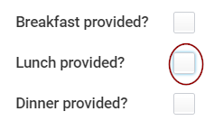  Click Done when finished.
- Click the Trash Can or Minus Button to Delete an Expense Report Line if needed. | For this step leave the current line in place.
- Attachments might be required at the line level. Add or drop files that relate to the expense line by clicking Select Files button. | Add the post-travel documents here.  Depending on the Expense Item, attachments might be required. If an attachment is required and is not attached, an error will display, which will prevent submission.
- Informational Only: Clicking Save for Later will generate a expense report number or continue saving the user’s work.  Clicking Cancel will cancel all the changes the user has made thus far. | For this activity, do not click either.
25. Click Submit . | Click Submit. This will trigger the next business process step.
- View your submission:  Who is up next?  What is the spend authorization status?  View the Process tab to view history  View more options by clicking Actions . | 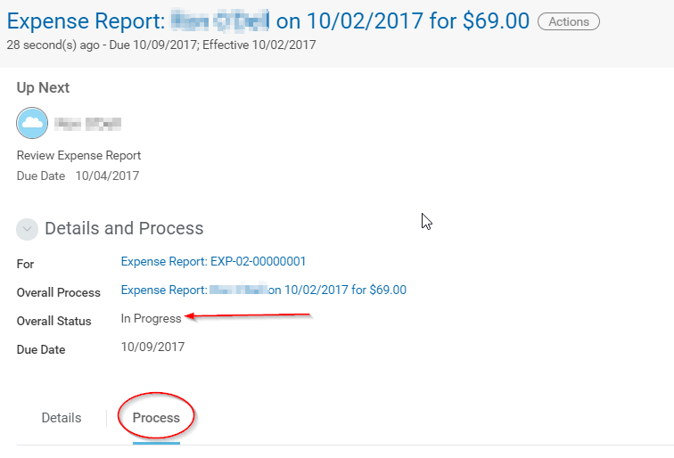
- At what step is the Expense Report awaiting action in the current Process History? Click on the Process tab. | 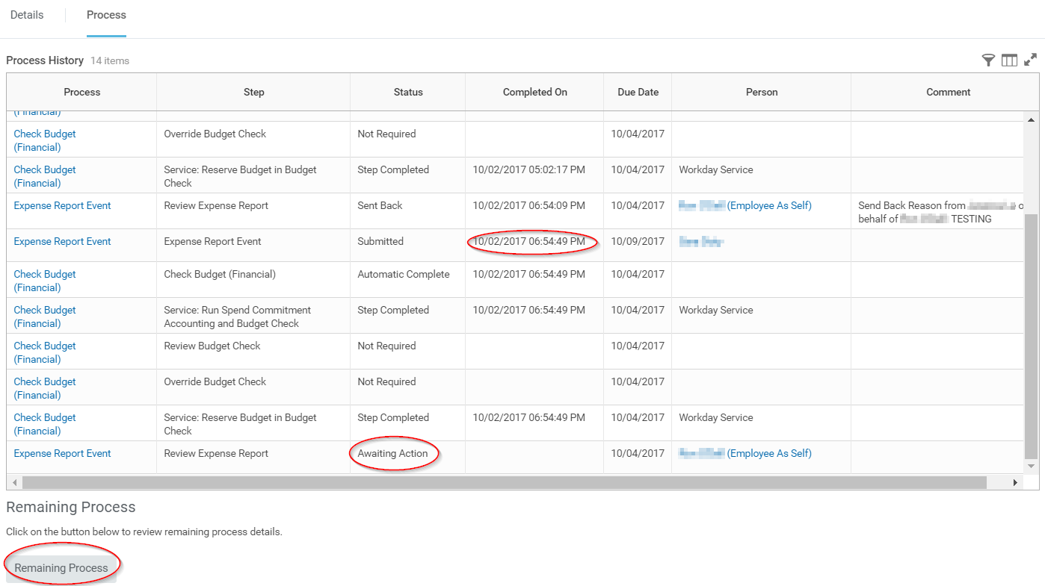
- Click on Remaining Process to view the potential next steps and users that will be responsible for completing the business process.  How is the expense report routed? (Hint: It depends on the worktag managers.) | 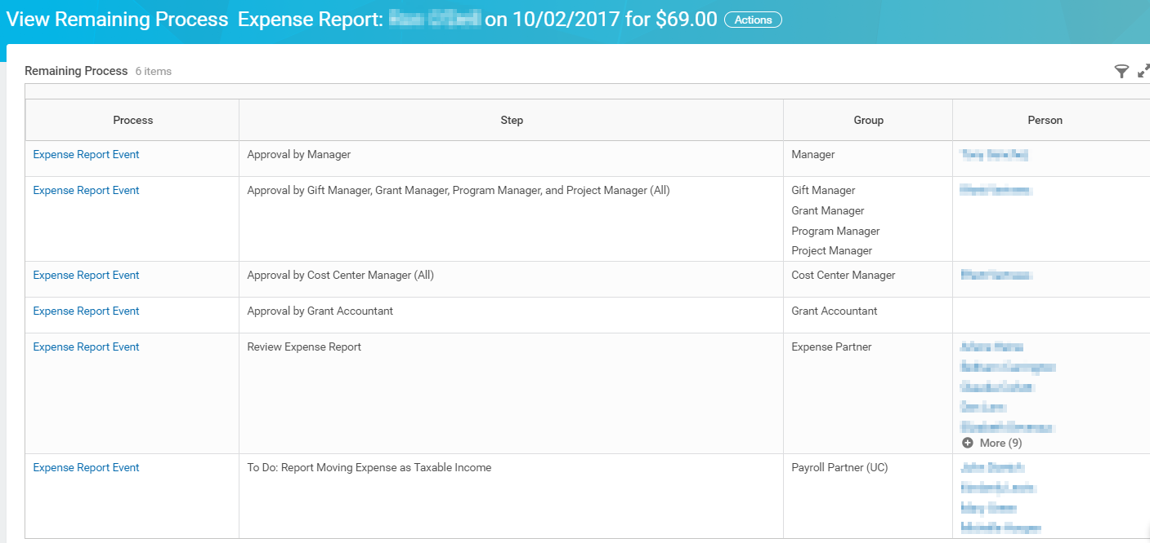
- Next Step: Find the Expense Report | How do you go back and submit, edit, or review an expense report?  Reports to run from Workday Search Bar:  - My Expense Reports (allows users to find their own)  - Find My Team’s Expense Reports (allows Manager’s to find those under their Supervisory Organization)  - Find Expense Report Lines for Organization  - EXP-02- (will return all that the user has access to view)  - The Archive will capture everything the user has Submitted
- What does a Completed Expense Report business process look like? | 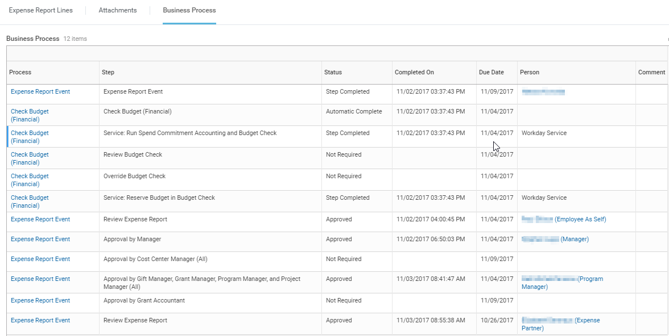

Notes:
Congratulations! You have completed this exercise.
End

Reference: Expense Report Statuses
This table describes the different statuses for an expense report.

Status | Description
Draft | You started creating an expense report but have not yet submitted it.
In Progress | You created and submitted an expense report, but it has not yet been approved or denied.
Approved | Your expense report has been approved.
Paid | A payment to you has been settled for this expense report.
Canceled | Your expense report has been denied.

Frequently Asked Questions:

What are all the possible Business Purposes available?
- Employee In-State Travel
- Employee International Travel
- Employee Out-Of-State Travel
- General Academic Non-Travel
- General Administrative Non-Travel
- Group/Team In-State Travel
- Group/Team International Travel
- Group/Team Out-of-State Travel
- Moving Expense
- Petty Cash/ Change Fund Establishment
- Petty Cash Replenishment
- Pre-Hire Expense
- Student In-State Travel
- Student International Travel
- Student Out-of-State Travel

I have the following Error, please help?
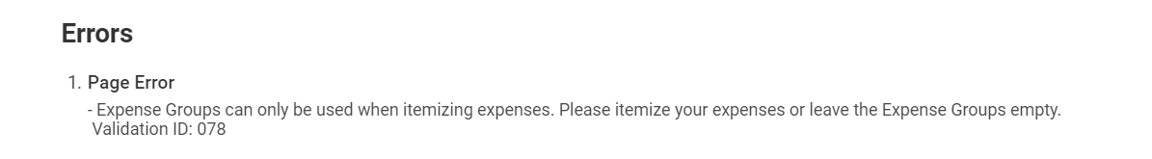
- Check to ensure that you have entered the proper Expense Item on the Line. Expense items like Lodging- Taxes and Fees should not be used on the Line; however, they should be used after clicking Itemize.

What are the correct Expense Items to use for Petty Cash?
- For Petty Cash/Change Fund Establishment, use the Expense Item: Petty Cash. For Petty Cash Replenishment, use the Expense Item appropriate for the expense (ie Meals-Groceries or Office Supplies).
How do I ensure that I don't lose data when working on an expense report?
- Workday recommends the following:
- The expense report should contain less than 50 lines.
- Don't open an expense report in multiple tabs of a browser when creating and editing expense reports.
- Click Save for Later frequently, even if you intend to enter more expenses during the same session.
To continue working on your report after saving, click Edit Expense Report.
Workday automatically takes a snapshot copy of your expense reports every 2 minutes. Workday uses the snapshot copy only if a session ends abnormally, such as if a browser crashes or a session closes abruptly. In this case, when workers access their expense report, they can either select the snapshot instance or continue working with the version saved before the snapshot was taken.
If a Workday service update occurs before a worker signs back in and accepts the snapshot, the most recent edits are lost. Workers should sign back in as soon as possible after an abnormal termination to accept the changes.
What do I do when I select the Use Recovered Changes option and don't see my changes?
- Workday recommends immediately canceling the expense report without saving it. Then re-open the expense report and select Yes, Use Recovered Changes.
Why do I receive errors that I'm missing information when I try to submit my expense report?
- You don't need all required details for your expense report when it's in draft mode, but your company requires them to submit the report for approval and payment. Also, expenses that are out-of-compliance with your organization's travel policies can return errors. After you click Submit, Workday validates that you included all required information, and that the expenses comply with your travel and expense policy.
I've received errors when working on an expense report in 2 different browsers simultaneously. Can you provide any recommendations?
- Workday recommends using only 1 browser while creating and editing expense reports. Working in multiple windows can cause conflicts when saving expense reports.

