How to E-sign with any computer

- Go to this URL: https://smallpdf.com/sign-pdf

- Under “sign a document” select “choose”
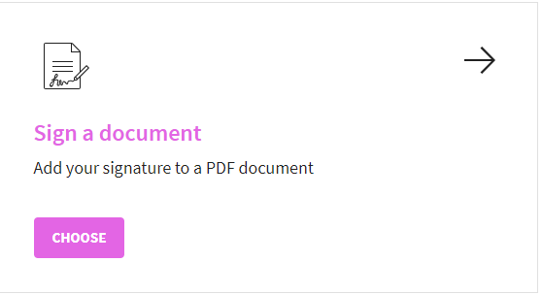
- You can drop your PDF into the pink box, select choose file, or upload from google drive.
- Select “place signature” in the upper left hand corner.
- Select “create signature”
- Use your mouse or tracking pad to draw a signature
- Select “save”
- Select (“apply”)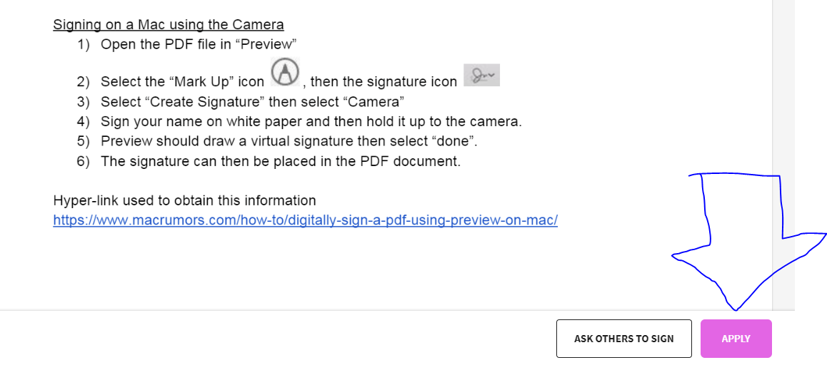
10) After you select apply, it will give you a download link with your signature on the document
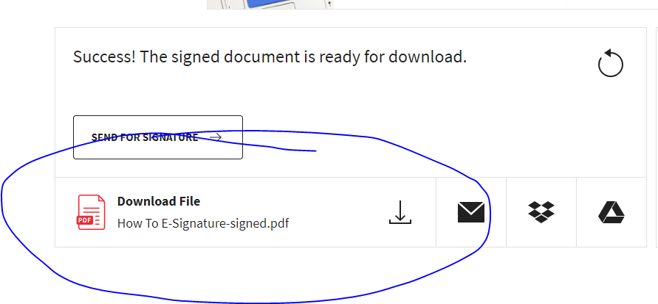
Mac
- Open the PDF file in the application “Preview”
- Select the “Mark Up” icon , then the signature icon .
- Select “Create Signature”, then “Click here to begin”
- Draw your signature on the trackpad, click any key when finished then click “done”
- The signature can then be inserted into a PDF document

Signing on a Mac using the Camera
- Open the PDF file in “Preview”
- Select the “Mark Up” icon , then the signature icon
- Select “Create Signature” then select “Camera”
- Sign your name on white paper and then hold it up to the camera.
- Preview should draw a virtual signature then select “done”.
- The signature can then be placed in the PDF document.

Hyper-link used to obtain this information
https://www.macrumors.com/how-to/digitally-sign-a-pdf-using-preview-on-mac/

