GUEST PASS
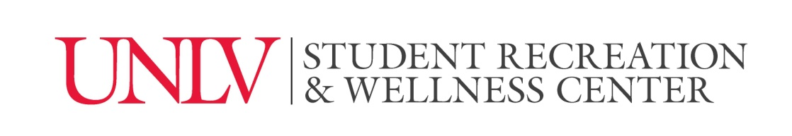

Student Recreation and Wellness Center
Assumption of Risk/Release of Liability Form

I, ______________________ (print name), acknowledge, understand and agree that participation in and/or use of the Student Recreation and Wellness Center (hereinafter “SRWC”) located at the University of Nevada, Las Vegas campus, is voluntary and that participation in and/or use of the SRWC can result in risk of injury regardless of the precautions taken by the SRWC.
Specific risks/hazards involved in participation in and/or use of the SRWC include, but are not limited to, the following:
- Wood, concrete, rubber, tile or other surfaces may be uneven, rough, slippery, contain holes and/or divots;
- Slips, falls and drowning may occur when using the pools in the natatorium;
- Walking, running, lifting of weights or use of any machines or other equipment may cause injury;
- Engaging in strenuous or any other activities may cause injury;
- _____Other;
- _____Other;
I voluntarily and freely choose to participate in and/or use the SRWC. I recognize and acknowledge that there are risks and hazards directly or indirectly involved in such participation in and/or use of the SRWC, not all of which can be identified with particularity or certainty and not all of which are described in this form. I voluntarily assume all risks associated with my participation in and/or use of the SRWC.
In consideration of my participation in and/or use of the SRWC, I expressly and knowingly release the Board of Regents of the Nevada System of High Education, on behalf of the University of Nevada, Las Vegas (hereinafter “UNLV”), its officers, agents, volunteers and employees, from any liability, claims, demands, losses, judgments, damages, causes of action of any kind and nature whatsoever, including attorneys’ fees and other expenses, which may arise from or in connection with my participation in and/or use of the SRWC.
In addition, I understand and agree that UNLV cannot be expected to control all of the risks articulated in this form and may need to respond to accidents and potential emergency situations. Therefore, I hereby give my consent for any and all medical treatment that may be required during my participation with the understanding that the costs of any such medical treatment will be my sole responsibility. UNLV does not carry medical or accident insurance for participation in and/or use of the SRWC.
I voluntarily and knowingly agree to protect, defend, hold harmless and indemnify UNLV, its officers, agents, volunteers and employees, against any and all liability, claims, demands, losses, judgments, damages, causes of action of any kind and nature whatsoever, including the defense costs, attorneys’ fees and any other expenses, which may arise from or in connection with my participation in and/or use of the SRWC. I understand the student’s rights and responsibilities outlined in the UNLV Code of Conduct and all other UNLV policies apply.
Finally, I understand that this Guest Pass transaction is non-refundable for any reason.
I represent that I am eighteen (18) years or age or older and have read, understand and agree to all of the terms and provisions contained within the SRWC Membership Assumption of Risk/Release of Liability Form.

Last Name: First Name:
Address: City/State: Zip:
Phone: Email:
NSHE ID #: Date of Birth: / / Male Female
In case of emergency, contact: Phone:
Participant Signature: Date: ______________________________
For Facility Attendant Use ONLY: Patron already has a household in RecTrac FA initials: Date:

