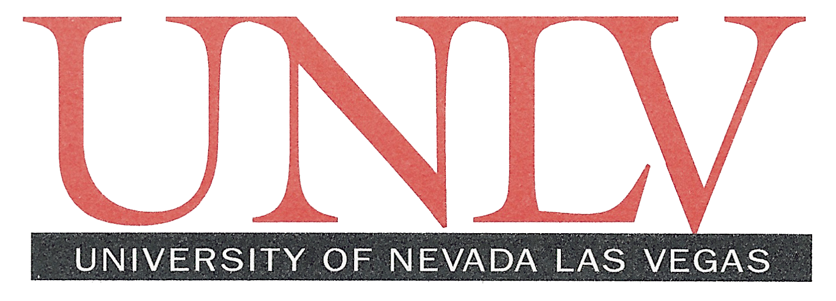

Living in a Seasonal World
Credit Card Authorization Form
Fax # (702) 895-4318
Please type or print in BLACK ink

Name (as printed on card):

Billing Address:

Phone Number: ( )

Type of Credit Card: (please circle one)

VISA MASTERCARD DISCOVER AMERICAN EXPRESS DINERS CLUB

Card Number:

Expiration Date: /

Amount: $

Description of Sales / Services: Registration for Living in a Seasonal World

I authorize the use of the above listed credit card to pay the fees listed above to the University of Nevada, Las Vegas. I understand that the credit card transaction will occur on the transaction date listed above for the amount I have indicated. I understand that fee payment deadlines, and/or late fees are my responsibility. I further understand that I may be charged a penalty fee if the credit card company denies my credit card. I understand that a facsimile or photocopy of this form with my signature on it is the same as an original. Please ensure that you complete this form in its entirety.

Card Holder’s Signature Date

