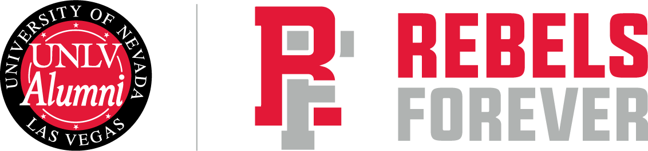

UNLV Alumni Association
Philanthropy Committee Overview
Updated January 1, 2026

Mission: The Philanthropy Committee cultivates volunteers and donors to support UNLV efforts through engagement, education, and peer-to-peer asks.
Primary Objectives: The Philanthropy Committee encourages and leads active participation through the gifts of time, talent and treasure for the alumni association and for the colleges and units across the UNLV campus. Additionally, the committee will actively work with the Division of Philanthropy & Alumni Engagement to appropriately and creatively thank those alumni who give of their time, talent and treasure. The Committee will also lead the planning and execution of the annual Fred C. Albrecht Scholarship Golf Tournament and other philanthropic events to benefit the Alumni Association as directed by the Board.
Chair: Maggie Hausbeck, margaret.hausbeck@unlv.edu, and Co-Chair: Perry Harris, perryharris50@gmail.com
Staff Liaison: Blake Douglas, blake.douglas@unlv.edu
Google group: philanthropy-committee-group@unlv.edu

Committee Members:
- Beau McDougall beaumcdougall@gmail.com
- Quinton Singleton, qrsingleton@gmail.com
- Fletch Brunelle, hfbrunelle@me.com
- Caleb Green, cgitnlv@gmail.com
- Jon Marshall, jonmarshall04@gmail.com
- Nadia Khan, nadiakhan5830@gmail.com

Related staff and departments:
- Blake Douglas, Executive Director, UNLV Alumni Association, blake.douglas@unlv.edu
- Kim McGrath, Director for Board and Volunteer Relations, kim.mcgrath@unlv.edu
Meeting Frequency: This Committee will meet a minimum of four times a year.
Meeting Dates & Times: The dates below are tentative until approved by the Chair and Committee.
Committee Goals:

