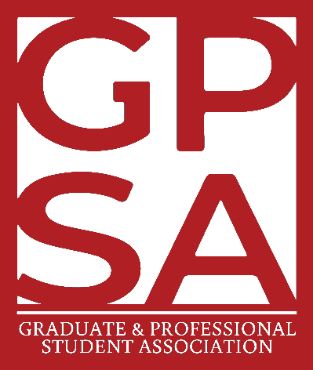
The UNLV Graduate & Professional Student Association
University of Nevada, Las Vegas

NOTICE OF PUBLIC MEETING

WAYS & MEANS COMMITTEE MEETING 45-07
Tuesday, March 3, 2026
6:00 PM
HYBRID PUBLIC MEETING:
IN PERSON: Graduate Commons, LLB 2141
4505 S Maryland Pkwy, Las Vegas, NV 89119, USA
VIRTUAL: ZOOM LINK
ZOOM PASSWORD: GPSAUNLV

IMPORTANT INFORMATION ABOUT THE AGENDA AND PUBLIC MEETING NOTE:

PERTAINING TO VIRTUAL MEETINGS:
Public Comment may be submitted via email to gpsa@unlv.edu.
Messages received by 9:00 AM on the day prior to the meeting, may be entered into the record during the meeting. Any other public comment form submissions and/or voicemails received prior to the adjournment of the meeting will be transcribed and included in the permanent record.
Members of the public wishing to listen to the meeting may do so via: https://unlv.zoom.us/j/7028952261

CONTINUED:
Below is an agenda of all items scheduled to be presented and considered at the meeting. Notification is hereby provided that items on the agenda may be taken out of the order and presented, two or more agenda items may be combined for consideration, and an agenda item may be removed from the agenda or discussion relating to an item on the agenda may be delayed at any time.
Some agenda items are noted as having accompanying reference material. Copies of the reference materials that are distributed at the meeting may be requested by emailing the Chair at gpsa@unlv.edu. Copies of any such materials will also be made available at unlv.edu/gpsa on the “Agendas and Minutes” folder of the appropriate meeting. Reasonable efforts will be made to assist and accommodate persons with a disability attending the meeting. Please email the GPSA Manager at gpsa@unlv.edu in advance so that arrangements may be made.
This meeting’s agenda has been posted in accordance with NRS 241.020. Agendas may also be also be available online at unlv.edu/gpsa/agenda in the appropriate session and meeting number folder.

PUBLIC COMMENT:
Public comment will be taken during this agenda item. No action may be taken on a matter raised under this item until the matter is included on an agenda as an item on which action may be taken. Comments will be limited to three minutes per person. Persons making comment will be asked to begin by stating their name for the record and to spell their last name. The Board Chair may elect to allow additional public comment on a specific agenda item when that agenda item is being considered. In accordance with Attorney General Opinion No. 00-047, as restated in the Attorney General’s Open Meeting Law Manual, the Chair may prohibit comment if the content of that comment is a topic that is not relevant to, or within the authority of, the Body, or if the content is willfully disruptive of the meeting by being irrelevant, repetitious, slanderous, offensive, inflammatory, irrational or amounting to personal attacks or interfering with the rights of other speakers.

WAYS & MEANS COMMITTEE MEMBERS
☐ Blanca Peña, Committee Chair
☐ Olalekan Balogun, GPSA Treasurer
☐ Chinonso Unegbu, Committee Vice Chair
☐ Lauren Gleave, Committee Member
☐ Trey Curtis-Brown, Committee Member
☐ Thomas “TJ” Crippen, Committee Member

All other members present will be available in the meeting minutes and listed below.

Members of the Public Present:

AGENDA
- CALL TO ORDER

- PUBLIC COMMENT INFORMATION ONLY
(See foregoing notation regarding public comment)
ROLL CALL
- APPROVAL OF MINUTES FOR POSSIBLE ACTION
Request is made for approval of minutes of previous meetings.
3a) CONSENT AGENDA:
  - Minutes for the February 3, 2026 (45-06) Ways & Means Committee Meeting as posted to the public GPSA Drive.
- REPORTS & RECOMMENDATIONS INFORMATION ONLY
4a) GPSA Treasurer Report
4b) Ways & Means Committee Chair Report – Council Meeting Updates
4b) GPSA Manager & Advisor
- UNFINISHED BUSINESS FOR POSSIBLE ACTION
Unfinished Business is any motion or action item that was under discussion and was postponed or moved to this meeting at the discretion of the public body as approved by the chair.
5a) Discussion & Approval of an Online Payment Account (Merchant ID) for the Cap & Gown Lending Program
GPSA Manager & Advisor Nia Smercina requests for the discussion and approval of an online payment account, also referred to as a Merchant ID, for the Cap & Gown Lending Program, now that the program has switched to cashless payments as of Fall 2025.
5b) Discussion & Approval of a New Rental Fee/Return Incentive Structure for the Cap & Gown Lending Program
GPSA Manager & Advisor Nia Smercina requests for the discussion and approval of a new rental fee/return incentive structure for the Cap & Gown Lending Program. Currently, the rental fee stands at $60 with a refund incentive of $40 upon return of graduation regalia.
- NEW BUSINESS FOR POSSIBLE ACTION
New business is any motion that is new to this meeting. All items will be for possible action unless otherwise stated.
6a) Discussion & Approval of GPSA Council Resolution 45-06
GPSA President Devin Lopez and Ways & Means Committee Chair Blanca Peña requests for a discussion and approval of GPSA Council Resolution 45-06: A Resolution in Support of an Inclusive Payment Structure for Graduate Student Government Officials.
6b) Call for New Business Items
Chair Peña requests a call for New Business agenda items. Agenda items not previously posted to this agenda may be raised for discussion for either the present or subsequent meeting.
- ANNOUNCEMENTS INFORMATION ONLY
- PUBLIC COMMENT INFORMATION ONLY
(See foregoing notation regarding public comment)
- ADJOURNMENT FOR POSSIBLE ACTION

