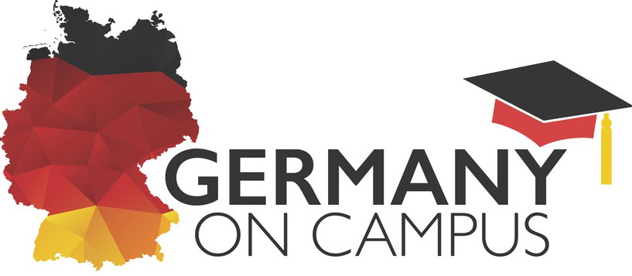
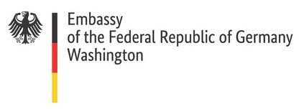

MONDAY, SEPTEMBER 29

Siemens Mobility: Transportation and Technology
Siemens’ Regional Construction Manager Rich Whitehead presents how the company combines the real and digital worlds. You may find just the right fit for your major and career, including: trains, rail automation, software systems, cybersecurity services & more. 4 -5 pm, FDH 109

Poster Exhibit Opening Reception
Enjoy light refreshments, mingle and browse posters showcasing connections between Germany, Nevada and UNLV. 5 - 7 pm, FDH Foyer. On display through Oct. 2 in BEH Foyer
TUESDAY, SEPTEMBER 30
Beer Styles and Brewing Traditions of Germany
Join Prof. Mackenzie’s “Beers of the World” class. Must be age 21+; RSVPs are required; IDs will be checked. This is a regular class session: please stay for the entire class. 11:30 am - 2:15 pm, HOS 434
Fritz Lang’s “M” film screening
See why Lang’s 1931 masterwork remains the blueprint for the psychological thriller even today, and learn how early German filmmakers influenced the genre. 6 - 9 pm, FDH 109

WEDNESDAY, OCTOBER 1

Boost Your Career with German: Panel Discussion
Learn from UNLV professors how German language skills can help open doors to your successful career in fields including the sciences, arts, humanities and more 4 -5 pm, BEH 240

“Taste of Germany” Food Station in the Dining Commons, 11 am - 2 pm
Guten Appetit! Sample German specialties including bratwurst, red cabbage, pretzels and more at a special station during the “Taste of UNLV” event. The first 35 students to RSVP win a free lunch!

THURSDAY, OCTOBER 2

Study in Germany Kaffee and Mixer
Meet UNLV students and alums who were recently in Germany. You’ll learn about their firsthand experiences, get insider insights on successful applications, and ask what you’ve always wanted to know. 4 -5 pm, BEH 235
Hosted by UNLV World Languages & Cultures RSVP via QR code, or click here.

