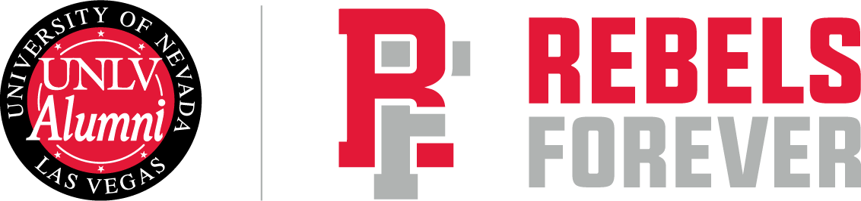

PUBLIC NOTICE
UNLV Latino Alumni Club Meeting

Wednesday, June 18, 2025 | 1 p.m.

AGENDA
Virtual Information:
https://unlv.zoom.us/j/94851837255?pwd=3KPyox7YoWWOEhR6O4QgAMa4TMcd6j.1&jst=2

Time Agenda Item Who/Speaker
9 a.m. 1. Call to Order Izack Tenorio
- Roll Call* Adrian Martinez
- Public Comment**
- ACTION ITEM: Adopt the Wednesday, June 18, 2025, agenda of the Latino Alumni Club.

1:05 p.m. 2. Event Recaps Izack Tenorio
- ACTION ITEM: Executive Board Vacancies

1:10 p.m. 2. Event Recaps Izack Tenorio
- INFORMATION AND DISCUSSION: Rebels Give
- INFORMATION AND DISCUSSION: Inaugural Latino Alumni Club Event
- INFORMATION AND DISCUSSION: UNLV Latinx Graduation Ceremony
- INFORMATION AND DISCUSSION: Executive board vacancies

1:15 p.m 3. Schedule Meetings Izack Tenorio
- INFORMATION AND DISCUSSION: 2025
- INFORMATION AND DISCUSSION: 2026

1:25 p.m 4. Start Subcommittee Work
- INFORMATION AND DISCUSSION: Mentoship
- INFORMATION AND DISCUSSION: Engagement
- INFORMATION AND DISCUSSION: Philanthropy
- INFORMATION AND DISCUSSION: Cultura
1:55 p.m. 5. Public Comment** Izack Tenorio

2:00 p.m 6. Adjourn Izack Tenorio

- * Agenda items may be taken out of order to accommodate persons appearing before the Committee and/or to aid in the effectiveness of the meeting at the discretion of the chair. A motion to reconsider an item may be made at any time before adjournment of this meeting. Similarly, if an item is tabled at any time during the meeting, it may, by proper motion and vote, be taken from the table and thereafter be the subject of consideration and action at any time before adjournment of this meeting.
- ** Under the Public Comment agenda item, members of the general public may bring matters not appearing on this agenda to the attention of the Committee. The Committee may discuss the matters, but may not act on the matters at this meeting. If the Committee desires, these matters may be placed on a future agenda for action. A time for public comment is provided at the conclusion of the meeting. The Chair reserves the right to call on individuals from the audience or to allow for public comment at any time. Time limit: A time limit of three minutes may be imposed on public testimony by the Chair in order to afford all members of the public who wish to comment an opportunity to do so within the timeframe available to the Committee.
- PLEASE NOTE:
- Public comment will be taken on each agenda item as it is heard. If you desire to provide general public comment or public comment on an individual agenda item, please dial-in with the details at the top of the agenda.
- NOTICES POSTED AT THE FOLLOWING LOCATIONS:
- UNLV Alumni Association website at https://www.unlv.edu/alumni/announcements and the Nevada Public Notice Website at https://notice.nv.gov

