The UNLV Graduate & Professional Student Association
University of Nevada, Las Vegas

NOTICE OF PUBLIC MEETING GPSA COUNCIL MEETING 42-02
FRIDAY, AUGUST 5, 2022
3:00 – 4:30 PM
VIRTUAL PUBLIC MEETING:
http://unlv.webex.com/meet/gpsa

IMPORTANT INFORMATION ABOUT THE AGENDA AND PUBLIC MEETING NOTE:

PERTAINING TO VIRTUAL MEETINGS:
This meeting will be held via teleconference only pursuant to Section 1 of the Declaration of Emergency Directive 006 (“Directive 006”) issued by the State of Nevada Executive Department. If a physical location is required for the meeting, participants may be able to access the livestream by visiting the Graduate Commons at the Lied Library 2nd floor.
Public Comment may be submitted via email to gpsapresident@unlv.edu.
Messages received by 9:00 AM on the Wednesday prior to the meeting, may be entered into the record during the meeting. Any other public comment form submissions and/or voicemails received prior to the adjournment of the meeting will be transcribed and included in the permanent record.
Members of the public wishing to listen to the meeting may do so via: unlv.webex.com/meet/gpsa

CONTINUED:
Below is an agenda of all items scheduled to be presented and considered at the meeting. Notification is hereby provided that items on the agenda may be taken out of the order and presented, two or more agenda items may be combined for consideration, and an agenda item may be removed from the agenda or discussion relating to an item on the agenda may be delayed at any time.
Some agenda items are noted as having accompanying reference material. Copies of the reference materials that are distributed at the meeting may be requested by emailing the Chair at gpsa@unlv.edu. Copies of any such materials will also be made available at unlv.edu/gpsa on the “Agendas and Minutes” folder of the appropriate meeting. Reasonable efforts will be made to assist and accommodate persons with a disability attending the meeting. Please email the GPSA Manager at gpsa@unlv.edu in advance so that arrangements may be made.
This meeting’s agenda has been posted in accordance with NRS 241.020. Agendas may also be also be available online at unlv.edu/gpsa/agenda in the appropriate session and meeting number folder.

PUBLIC COMMENT:
Public comment will be taken during this agenda item. No action may be taken on a matter raised under this item until the matter is included on an agenda as an item on which action may be taken. Comments will be limited to three minutes per person. Persons making comment will be asked to begin by stating their name for the record and to spell their last name. The Board Chair may elect to allow additional public comment on a specific agenda item when that agenda item is being considered. In accordance with Attorney General Opinion No. 00-047, as restated in the Attorney General’s Open Meeting Law Manual, the Chair may prohibit comment if the content of that comment is a topic that is not relevant to, or within the authority of, the Body, or if the content is willfully disruptive of the meeting by being irrelevant, repetitious, slanderous, offensive, inflammatory, irrational or amounting to personal attacks or interfering with the rights of other speakers.

EXECUTIVE BOARD

PRESIDENT
◻ Nicole Juliana Thomas - Present
VICE PRESIDENT
◻ Godson Ebenezer Adjovu - Present
TREASURER
◻ Drue Sahuc - Present
SECRETARY
◻ Rosedaveia Howell - Present

2022-2023 COUNCIL REPRESENTATIVES

College | Department | Name | Attendance
Lee Business School: | Business Administration | Benjamin Bishop | X
 | Economics | Ashley Lovell
College of Education: | Teaching & Learning | Claudia Chiang-Lopez | X
 | Educational Psychology & Higher Education | Jennifer Fletcher | X (Voter)
College of Engineering: | Civil & Environmental Engineering | Meena Ejjada | E
College of Fine Arts: |  | VACANT
College of Hospitality: | Hospitality & Hotel Administration | Jaimi Garlington | A
Integrated Health Sciences: | Health Physics & Diagnostic Sciences | Devin Peart | E
 | Kinesiology & Nutrition Sciences | Alan Garcia | X (Voter)
 | Brain Health | Amber Eddy | E
Boyd School of Law: |  | VACANT
College of Liberal Arts: | Psychology | Michael Fensken | X
School of Medicine: | Couple & Family Therapy | Emily Laurita | X
School of Nursing: |  | VACANT
School of Public Health: |  | VACANT
College of Urban Affairs: | Public Policy & Leadership | Sergio Bustos | A
College of Sciences: | Life Sciences | Anthony Lomando | X
 | Mathematical Sciences | Jorge Reyes | X
School of Dental Medicine: |  | VACANT
*Members may have been appointed by their department between the time of agenda posting and the meeting. All other members present will be available in the Minutes and listed below.

Members-at-Large Present:

Members of the Public Present:

AGENDA
- CALL TO ORDER

- PUBLIC COMMENT INFORMATION ONLY
(See foregoing notation regarding public comment)

None.
ROLL CALL
- APPROVAL OF MINUTES FOR POSSIBLE ACTION
Request is made for approval of minutes of previous meetings.
3a) CONSENT AGENDA:
  - Minutes for the June 2022 (42-01) Council Meeting as posted to the public GPSA Drive.
Motion to approve minutes. Unanimous yay vote 5:0:0.
- REPORTS & RECOMMENDATIONS INFORMATION ONLY
4a) GPSA Executive Board & Committees
    - President
      - Board of Regents & GA Stipends Update, UNR Partnership
        - President Thomas introduces the plan for lobbying in Reno for GA stipends. President Thomas is in communication with the Vice President of Student Affairs to assess the possibility of transforming houses around campus into student housing.
    - Vice President
      - Sponsorship Updates
        - Vice President Adjovu states that the Sponsorship committee reviewed 41 applications for the regular cycle and 36 applications were approved and 5 applications were rejected. For the emergency cycle, there were 3 applications which 2 applications were approved, and 1 application was rejected. For the regular cycle, the total amount awarded for the 36 applications was $28,914.78. For the 2 emergency applications that were funded, $1,700 was funded. The Sponsorships committee is currently working on modifications to the application portal for sponsorship applications.
    - Treasurer
      - Budget Report
    - Secretary
      - No updates.
4b) GPSA Business Manager & Advisor
- Advisor Smercina shared an image of the shirts that will be given out at student open house August 29th, 2022 and these shirts will also be for sale in the graduate commons after open house. Advisor Smercina discusses the Sponsorship shifting into the Team Dynamics platform to make the process easier for students and the Sponsorship Committee. Also, the sponsorship cycles will be changing to where there will no longer be the 4 regular funding cycles and emergency cycles. There will now be rolling deadlines on the 20th of every month. Students will be advised to apply within 60-90 days before their activity and if there is an issue with submitting by the advised deadline, they will automatically go into an appeal process where the student will apply for an appeal. There will also be no more reimbursement for the sponsorship funding, funds will now be disbursed on an upfront basis. The plan is that Masters/2-year programs will receive $2,500 per year for their sponsorship funds. Professional/PhD/3-4+ year programs will receive $5,000 per year for their sponsorship funds. Advisor Smercina is also continuing the search for an admin for GPSA but other administrative duties have taken precedence, but it is still being worked on.
4c) UNLV Campus-Wide Committees
(Representatives serving on any external committee on GPSA behalf may use this time to provide updates)
    - Other External committee updates
      - None.
4d) UNLV Departments/ Units
    - Graduate College: Dean Crittenden; Assistant Dean Burke
  - Dean Crittenden introduced themselves and expressed support for GPSA and GPSA’s initiatives.
- UNFINISHED BUSINESS FOR POSSIBLE ACTION
Unfinished Business is any motion or action item that was under discussion and was postponed or moved to this meeting at the discretion of the public body as approved by the chair.
None.
- NEW BUSINESS FOR POSSIBLE ACTION
New business is any motion that is new to this meeting. All items will be for possible action unless otherwise stated.
6a) Consideration and Approval of GPSA AY 2022-2023 Funding Allocations
President Thomas calls for the discussion and approval of funding allocations for the upcoming year. Upcoming projects, partnerships, scholarships, grants, and lobbying efforts will be considered as items for potential funding allocation.
Motion by Alan Garcia
Second by Drue Sahuc
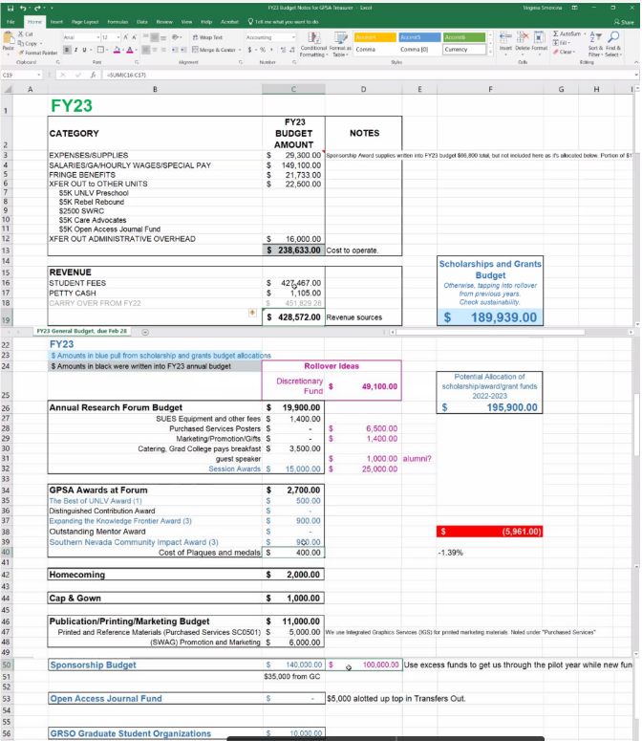
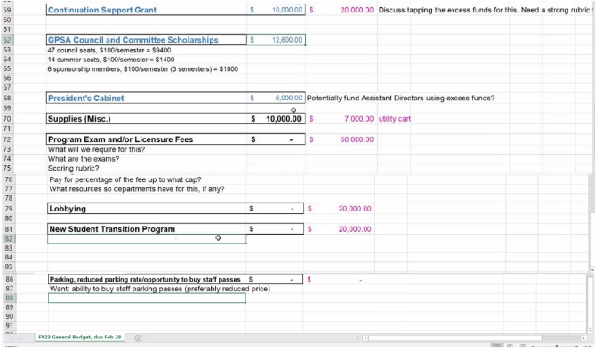
6b) Appointment of Council Representatives Committees
President Thomas requests time for the discussion and approval of GPSA Council Members to serve on internal or external GPSA and Graduate College committees.
    - Approvals: Anthony Lomando, Graduate Course Review Committee; Jennifer Fletcher, Graduate Programs Committee
      - Motion by Jennifer Fletcher, Second by Benjamin Bishop
      - Postdoctoral Affairs: Claudia Chiang-Lopez
      - Graduate Course Review: Anthony Lomando
      - Graduate Programs Committee: Jennifer Fletcher
      - Approve council members to those committees, unanimous yay vote 8:0:0
6c) Call for New Business Items
Items for consideration at future meetings may be suggested. Discussion is limited to description and clarification of the subject matter of the item, including the reasons for the request; emergency items added at the discretion of the President (GPSA Bylaws Article IV, Sec.3).
None.
- ANNOUNCEMENTS INFORMATION ONLY
    - Welcome Day is all day August 25th, 2022.
    - Student Open house on August 29th, 2022 10:00am – 4:00pm
- PUBLIC COMMENT INFORMATION ONLY
(See foregoing notation regarding public comment)
None.
- ADJOURNMENT FOR POSSIBLE ACTION

Motion to adjourn meeting 4:44pm, August 5, 2022.

