Minor in Unmanned Autonomous Systems
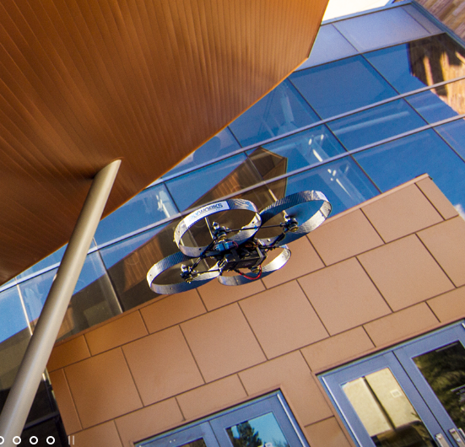 | The Howard R. Hughes College of Engineering is excited to announce a new, interdisciplinary minor degree program in unmanned autonomous systems (UAS) to begin in Fall 2014. With UNLV's proximity to accessible airspace this minor creates an ideal setting for learning Unmanned Autonomous Systems (UAS). The minor degree will provide the necessary background for students to apply their majors for applications in unmanned surveillance, data collection, and autonomous operations. The courses will consist of key engineering and computer science courses related to UAS technologies, UAS Privacy Course and UAS pilot training courses.
How to enroll
Students entering this minor program must have engineering majors or computer science. Students with science and math major need to contact program coordinator for guidance. Students must apply at least two semesters prior to graduation, and need to be approved by the minor program coordinator.

Course requirements
Students must complete 9 credits of UAS core courses and 12 credits of elective courses in the following specialty tracks. No more than nine (9) credits can be counted toward major degree.

UAS Core Courses (9 credits)
EGG 370¹ UAS Design and Applications
EGG 470/670² UAV Simulation and Testing
LAW 432 Privacy, Publicity & Defamation

Specialization Tracks (12 credits)

Specialization Track | Elective Courses
Autonomous System Design | ME 110 Private Pilot Ground School  ME 242 Dynamics  ME 380 Fluid Dynamic  ME 465 Composite | ME 482 Aerodynamics  ME 425 Robotics  ME 421 or EE 370 Feedback Control Systems  EE 475 Autonomous Systems and Control
Control | EE 360 Signals and Systems I  EE 370 Feedback Control Systems | EE 472 Digital Control Systems  EE 475 Autonomous Systems and Control
Communication | EE 360 Signals and Systems I  EE 361 Signals and Systems II  EE 432 Antenna Engineering | EE 460 Analog and Digital Communications  EE 466 Wireless and Mobile Communication  CpE 400Computer Communications Networks
HCI (Human-computer Interaction) | CS 135 Computer Science I  CS 351 Introduction to Multimedia  CS 420 Human-Computer Interaction | CS 482 Artificial Intelligence  CS 465 Computer networks I  CS 479 Introduction to Digital Image Processing

