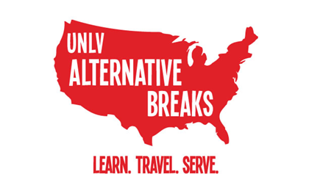 | Alternative Breaks Travel Grant Application

- Fill out and print this application.
- Attach this application to your completed Alternative Breaks application.
- Turn in your completed application packet to SU 316.
Travel grants are awarded to select participants. Grant recipients are expected to participate in all pre-trip meetings and will be asked to share their experience with the UNLV community through a presentation or other approved project.

Please check all of the following that apply:
- I have attended a UNLV Alternative Break trip before.
- I have received a travel grant for a UNLV Alternative Break trip before.
- I am a first-generation student who either receives the Pell grant or is qualified for one.
- I am requesting a deposit waiver.
Please explain below to help the program understand the context; if you are not requesting a deposit waiver, continue to the next question.

What amount of the trip cost are you able to pay for? (Minimum: $50) ____________
The lowest travel grant a participant may receive is $50. The $50 is due to Student Engagement & Diversity, SU 316, by the trip registration deadline. The deposit is refundable if the program does not offer you a place on a trip or if the trip is cancelled. The payment is not refundable if we offer you a trip spot and you decline or cancel.

Community Sharing:
Travel grant recipients will be invited to present about their Alternative Break Trip experience at Java and Justice. We will update you with more information about opportunities to share!

Short Answer Questions:
Please answer the following questions on a separate page (in addition to the short answer questions on the Alternative Break Trip Application). No more than 200 words each, please.
What are the circumstances that make the full trip cost not affordable for you? How would not receiving this travel grant affect your ability to attend the trip?

What skills, experiences and traits will you contribute as an Alternative Break Trip team member? How will you enrich the Alternative Break trip community?

