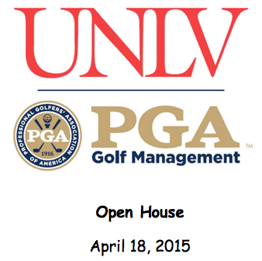

On behalf of the UNLV PGA Golf Management Program, we would like to invite you to our Spring Open House. You will enjoy a campus tour, lunch, meet and greet with our staff and students, and an opportunity to play golf at one of our home courses, Las Vegas National Golf Club.

Currently, the UNLV PGA Golf Management Program is one of eighteen schools in the country accredited by the PGA of America. By attending the Open House, you will gain greater knowledge of the PGA Golf Management curriculum and our degree program requirements. Also, you will learn about our active student association and how Las Vegas is a unique and positive setting for aspiring golf professionals.

Please use the link below to register for this years Open House event.

Register Now

Itinerary
8:00am-8:30am- Breakfast and Meet/Greet (Student Union Room 218)
8:30am-10:30am- Campus tour
10:30am-12:30pm- Orientation and Lunch with PGM faculty and current students
*************************************************************************
Golf at Las Vegas National Golf Club
Tee times starting at 2:00pm
9 holes FUN format!!!!
*************************************************************************
Preferred accommodations (see attachment)
Hyatt Place-Located just minutes from the UNLV Campus
The Fairfield Inn-Located just minutes from the UNLV Campus
Cost: $110 per person, which includes breakfast, campus tour, lunch, and golf (Parents/GUEST ONLY)
$75 per prospective student, which includes breakfast, campus tour, lunch and golf
$70 per person, which includes breakfast, campus tour and lunch only
Please contact Kendall Murphy regarding any questions via email at kendall.murphy@unlv.edu. We thank you for your interest in our program, and wish you continued success.

