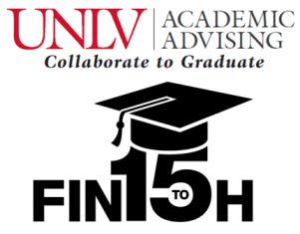

Nontraditional Scholarship Application

In honor of National Nontraditional Student Week (Nov. 3rd – 7th), we are awarding two deserving nontraditional students with a $200 bookstore scholarship that can be used at UNLV’s bookstore. Please see the message below and ask yourself if you are a nontraditional student. If so, we encourage you to apply!

Am I a nontraditional student?
If you have been out of school for some time, or if you balance school, work, family, home and extracurricular activities, then you know the challenges of being a nontraditional student. Nontraditional students include those who:
- Come to college for the first time after many years of employment
- Return to college to complete a degree after significant time away from school
- Work full-time jobs while going to school
- Take night classes
- Are parents, military veterans or part-time students

Applicant Information
Name:
 | NSHE ID #: |  | Phone:
 | Current Major: |  | Email:

Applicants MUST
Have a 2.5 or higher cumulative UNLV GPA and/or transfer GPA |  | Answer 3 essay questions (see below) |  | Have an interruption of 2 or more years in their educational studies

Signature
Please sign and date to certify that the information on this application is correct.
Signature of applicant: |  |  |  | Date:

In addition to the form above, please answer the following questions:
- What challenges have you overcome as a nontraditional student at UNLV?
- What does earning an education from UNLV mean to you as a nontraditional student?
- What advice would you give to prospective nontraditional students considering returning to college or attending for the first time?

Please submit all scholarship applications to John Starkey via e-mail at John.Starkey@unlv.edu by 4:00pm on November 14th.
http://www.unlv.edu/nontraditionalstudents/

