
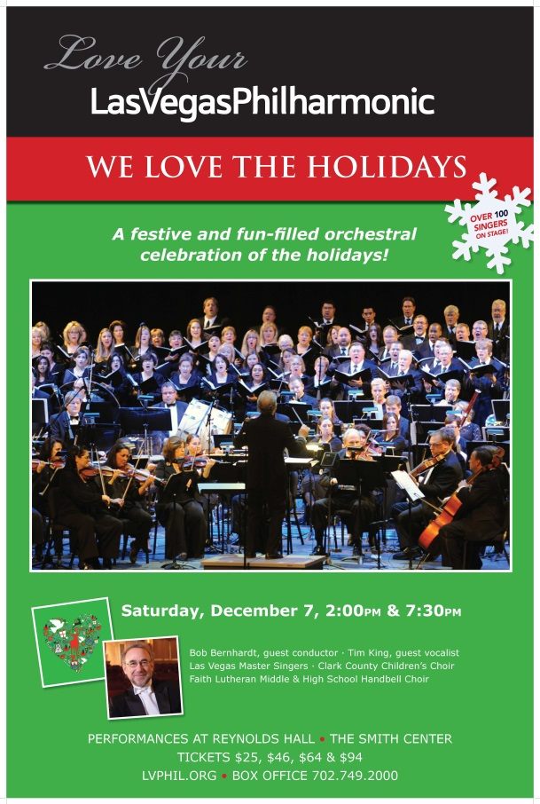
We Love The Holidays!
Pops II Concert
Saturday, December 7 at 2:00 p.m. & 7:30 p.m.
Reynolds Hall at The Smith Center
Bob Bernhardt, guest conductor
Tim King, guest vocalist
Las Vegas Master Singers
Clark County Children’s Choir
Faith Lutheran Middle & High School Handbell Choir
Tis the season! Join us for a jolly, fun-filled celebration of the holidays – the only holiday event that features your Las Vegas Philharmonic. Charismatic conductor Bob Bernhardt returns to lead two performances of orchestral and choral favorites with many special guests on stage and much musical merriment.
TICKET OFFERS
50% off Philharmonic Concert Tickets for UNLV Students!
The Las Vegas Philharmonic offers 50% off the ticket price for students. Must show valid student ID.
Price Level A: $94 / UNLV Discount Rate: $48.50
Price Level B: $64 / UNLV Discount Rate: $33.50
Price Level C: $46 / UNLV Discount Rate: $24.50
Price Level D: $25 / UNLV Discount Rate: $14.00
Discount rate includes $3 facility fee
$15 RUSH TICKETS!
On the night of the show, take advantage of our $15 RUSH OFFER! Arrive at The Smith Center box office 20 minutes before the Philharmonic concert starts to purchase balcony tickets for only $15! Valid with UNLV student ID only.
For more information, contact the Philharmonic office at 702.258.5438.

