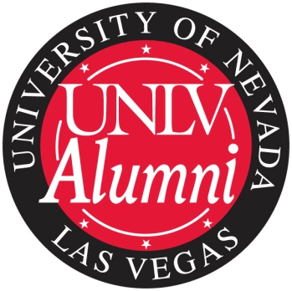

BOARD OF DIRECTORS
SERVICE AWARD
In recognition of her outstanding commitment and dedication to the UNLV Alumni Association, I hereby issue this special award in honor of [his/her] contributions.
[NAME]
For service to the UNLV Alumni Association [Chapter] Board of Directors, [Years of Service]

_____________________________________________________
[Chapter President’s Name], President
[Date]

