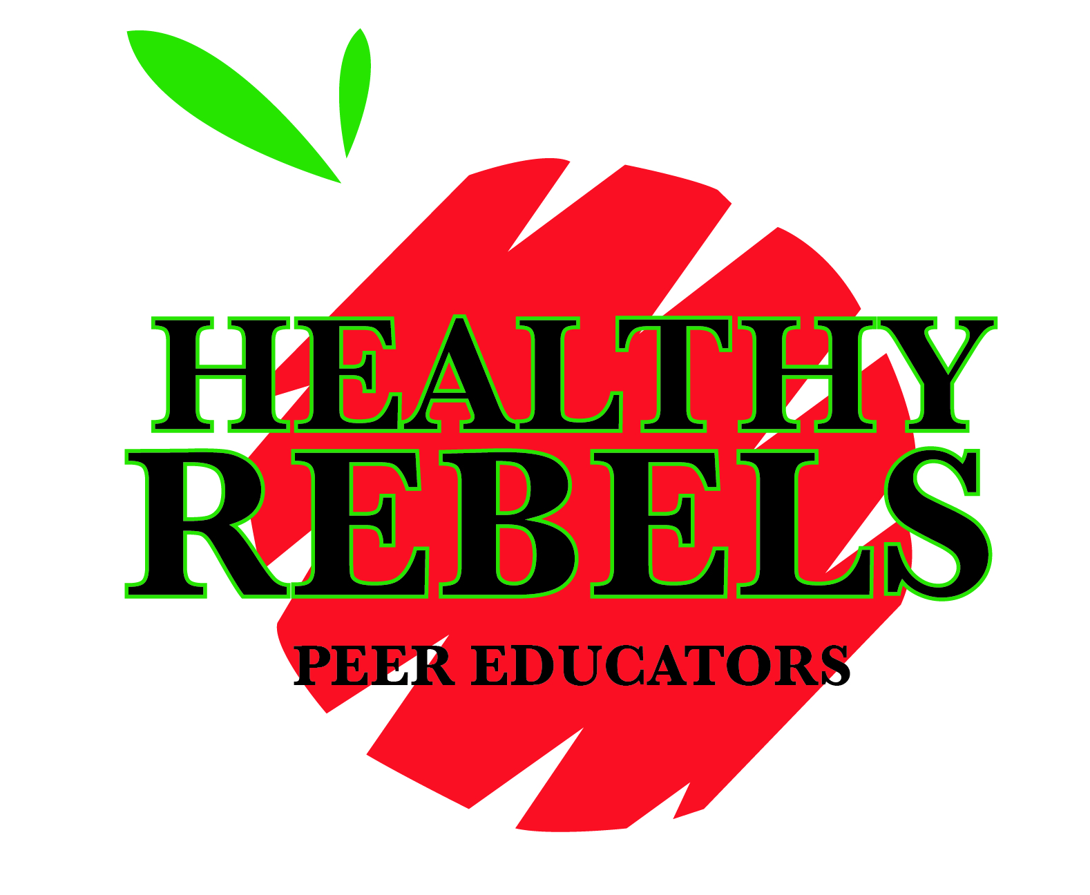
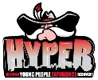

Program/Presentation Request

Request for Presentation &/or Program
- Don’t cancel your class! Professional staff, trained Healthy Rebel Peer Educators and peer mentors in our collegiate recovery group HYPER, may be available to present to UNLV academic classes, departments, student organizations, residence halls, etc.
- Programs may be tailored to your specific group or topic area, are evidence-based, interactive and include campus resources.
- We require at least 14 business days advance notice to schedule and prepare your session.
- Please complete this form & submit via email to starr.wharton@unlv.edu. We look forward to working with you!

Contact Information
Your Name: |  |  |  |  | Today’s Date:
NSHE #: |  |  |  |  | Preferred Date/Time |  |  | Date:  Time:
RebelMail or UNLV email Address: |  |  |  |  | Alternate Date/Time |  |  | Date:  Time:
This program is for:  Academic Class: # & Section (i.e. BUS103, 1001):  University Department:  Student Organization:  Residence Hall:  Other: |  |  |  |  | Preferred Location:  (NOTE: You are responsible for reservation request, equipment, projector, internet, setup, associated costs, etc.) |  |  | Building:  Room #:  Is this a Smart Room?:
 |  |  |  |  | Estimated # of attendees (NOTE: 10 minimum attendees for non-academic programs)

How did you hear about us?
 | Website/FB/Flyer |  |  | Friend/Colleague/Classmate |  |  | In Class/Campus Event

Requested Topic Areas
If the topic area you are interested in is not listed, please describe under “Other”.
 | Keep Your Rebel Covered:  Safer Sex/STD/Is, HIV/AIDS, relationship communication |  |  | Rebels DeStress:  Stress management, sleep, mental health concerns, how to help a friend |  |  | HYPER (Helping Young People Experience Recovery):  What is recovery all about? How to help a friend/significant other/family member who’s addicted/in recovery
 | Rebels Against Impaired Driving:  Alcohol choices/awareness, how to help a friend, impaired/distracted driving |  |  | Rebel Heart Check:  Physical activity, nutrition, cardiovascular health, nutrition-stress-fitness connection |  |  | Peer Education Leadership:  Certified Peer Educator training, how to become a peer educator/mentor/advocate
 | Recreational & Illicit Drugs |  |  | Cancer Awareness |  |  | Body image, disordered eating
 | Student Recreation & Wellness Center (SRWC) Overview:  Programs/services/resources |  |  | Other (please describe):

Acknowledgement of Request Submission
We will contact you via email to confirm receipt & address any concerns regarding of your request. We will make reasonable effort to accommodate your request, pending staff & resource availability. If you have any questions/concerns, contact starr.wharton@unlv.edu, 702-895-0288.
If completing electronically, I acknowledge that typing my full name is my signature.
Signature |  |  |  |  |  |  | Date
WP Staff Use Only
Date Received: By:

Granted/Not Granted (reason)/On Hold (reason):

