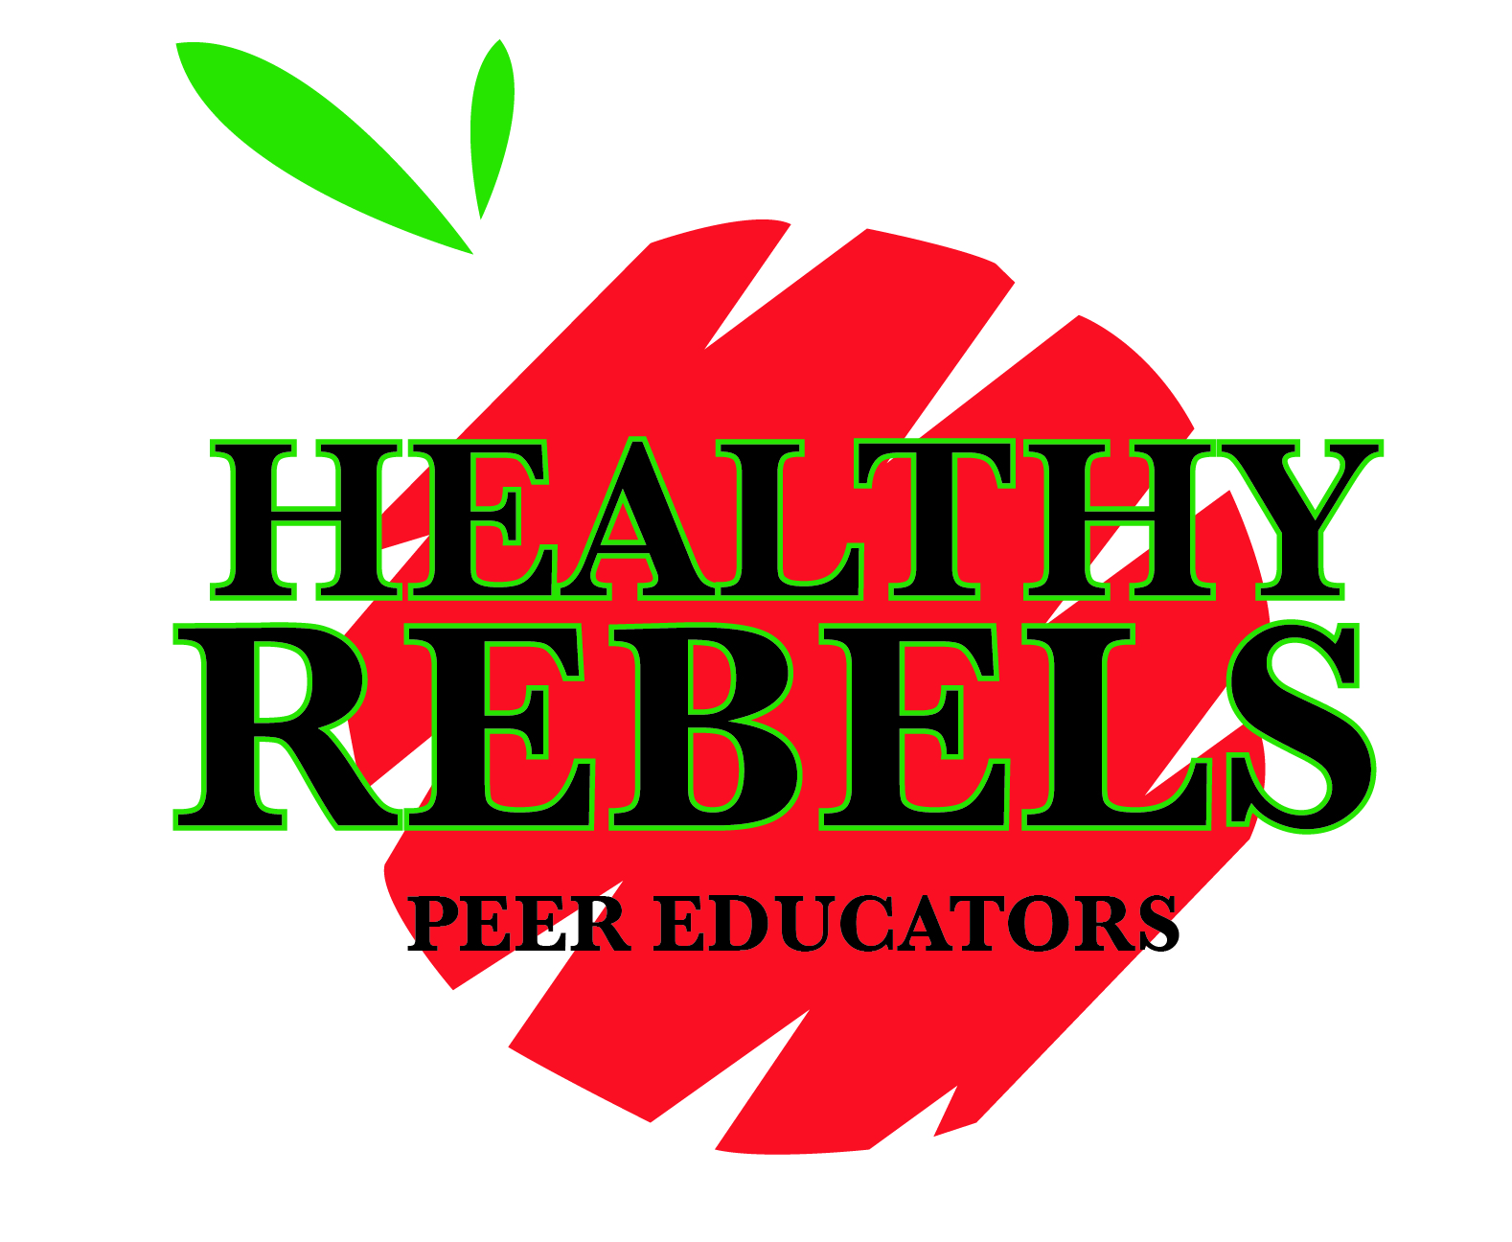

Healthy Rebel Peer Educators

Peer Educator/Peer Leader Application

Contact Information
Name: |  |  |  |  |  | Date:
NSHE ID: |  |  |  |  |  | Year in School:
Major: |  |  |  |  |  | Expected Graduation Date:
Street Address: |  |  |  |  |  | City/State/Zip
Phone: |  |  |  |  |  | RebelMail Address:

How did you hear about Healthy Rebel Peer Educators?
 | Website/FB/Flyer |  |  |  | Friend/Colleague/Classmate |  |  | In Class/Campus Event

What wellness & safety topics are you MOST interested In? (check all that apply)
 | Safer Sex & Relationships |  |  |  | Stress & Time Management |  |  | Alcohol & Other Drugs Awareness
 | Physical Activity |  |  |  | Food & Nutrition Choices |  |  | Impaired & Distracted Driving
 | Other:

Details
Please list all extracurricular/volunteer activities you are involved in at UNLV & off-campus (i.e. local, regional, national)
What does the term “peer leader” mean to you?
Why are you interested in becoming a Healthy Rebel Peer Educator?

Acknowledgement of Application
Please read the following carefully before submitting your application. If you have any questions/concerns, contact starr.wharton@unlv.edu, 702-895-0288.
If selected to become a Healthy Rebel Peer Educator, I understand that I will be required to complete a 12-hour Certified Peer Educator™ Training (fees apply) or an academic course in Peer Education Leadership, plus any applicable Rebel Wellness Zone program/event trainings. Courses/Trainings are held variable semesters as needed.
I acknowledge that if selected as a Healthy Rebel Peer Educator, I will be a role model, leader, advocate and educator to my peers. I will represent the Student Organization, Rebel Wellness Zone, Student Recreation & Wellness Center, and UNLV wherever I may be. I understand that this includes my choices inside & outside the UNLV campus-community. If completing electronically, I acknowledge that typing my full name is my signature.
Signature |  |  |  |  |  |  |  | Date
Submit this application to Starr Wharton, Assistant Director for Wellness Promotion, UNLV Rebel Wellness Zone or by email to starr.wharton@unlv.edu.
Applications will be reviewed and candidates contacted.
Thank you for your application!

